|  |
| --- |
| Assembling aneuploid genomes from short reads: PLOEST and POLYHAP-G  Supplement material |

# S.pastorianus CBS1483 Illumina & Simulated Data stats

|  |  |  |  |
| --- | --- | --- | --- |
| Insert size | Number of reads | Reads length | coverage |
| 180bp | 9.26 * 10⁶ | 100 bp | 52.2 |
| 500bp | 17.2 * 10⁶ | 100 bp | 68.8 |
| 3kb | 40.1 * 10⁶ | 50 bp | 80.2 |
| 8kb | 36.3 * 10⁶ | 50 bp | 72.7 |

Table S.pastorianus CBS1483 Sequenced data statistics

Estimating insert size and insert size standard deviation from the S.pastorianus CBS1483 libraries to recreate simulated reads of same characteristics:

1) Align the CBS1483 paired-end data in a combined way (both ends) against the CBS1483 reference genome (providing both fastq files to the bwa-0.7.13 aligner) .

2) Extract information from the SAM/BAM files (TLEN field=fragment size) selecting only the number in the .bam’s 9th column of those paired-end read pairs that are uniquely aligned against the genome.

3) Calculate the mean of the distribution of TLEN numbers generated in step 2. Ie: mean fragment size(data)=3364

4) Subtract length of the sequenced end pair read (2x50 bp or 2x100 bp) from the mean fragment size to get the insert size. ie: 3364-(2x50)=3264 µ(data)=3264 std(data)= 9.78% of µ (WRITE THIS WITH GENERAL FORMULA)

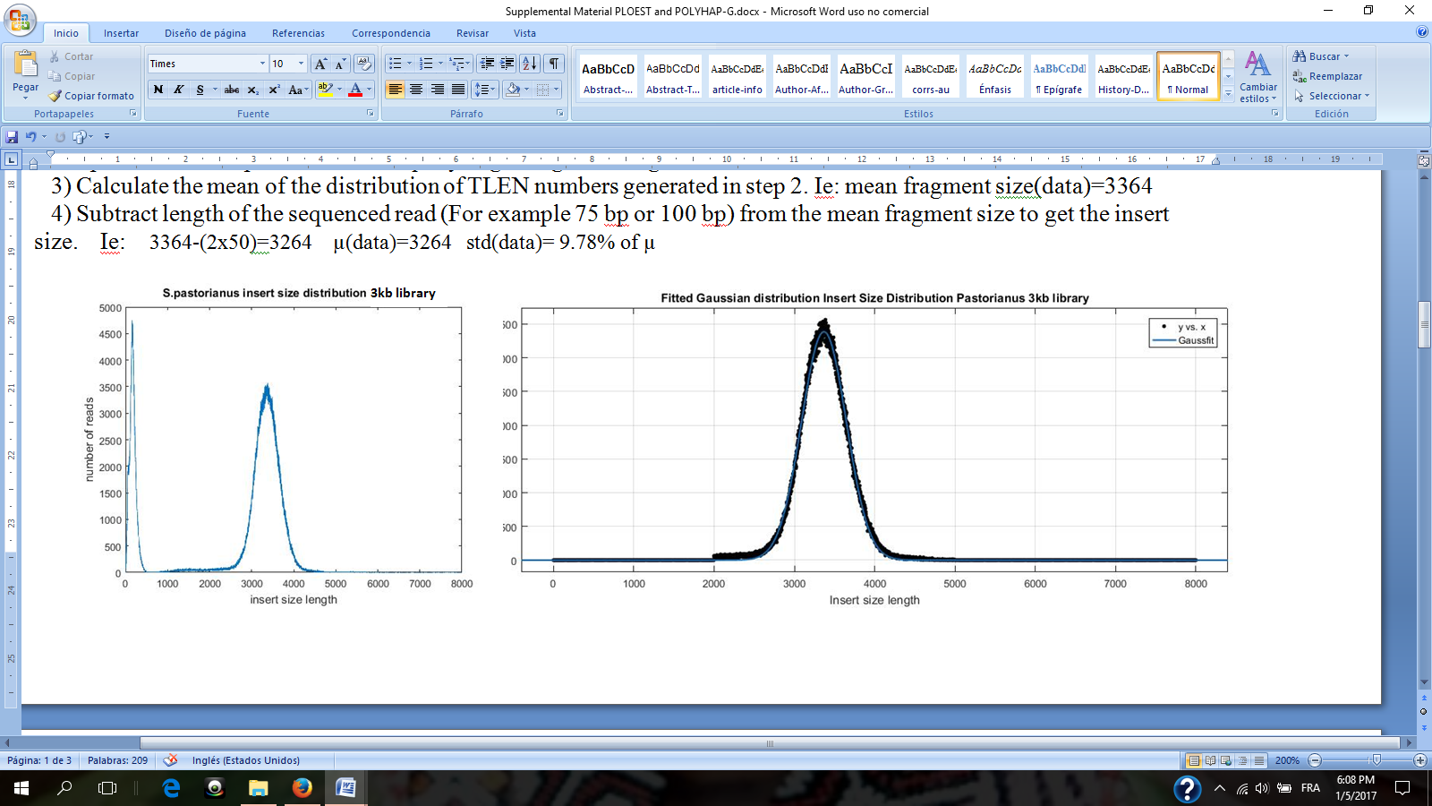

Figure 1. Insert size mean and standard deviation of 3kb library. After fitting a Gaussian distribution to the insert sizes of the library with Matlab, we obtain the mean and its standard deviation. The first cluster at the left side of the insert size distribution is ignored, considered to be error reads.

|  |  |  |
| --- | --- | --- |
| # Positions | 3637706 | 100% |
| # Passes | 3313517 | 91.03% |
| # No Passes (Variations) | 326272 | 8.96% |
|  |  |  |
| # Amb (SNP’s) | 16429 | 0.45% |
| # Del | 92814 | 2.55% |
| # Low Coverage | 206209 | 5.67% |
|  |  |  |
| # Del/LowCov | 8336 | 0.23% |
| # Del/Amb | 2371 | 0.07% |
| # Amb/LowCov | 104 | 0.3% |
| # Del/Amb/LowCov | 9 | ... |

Table Variant calling on pastorianus reads

over cerevisiae reference (chromosomes1-4 &10)



Figure 2 After aligning CBS1483 S. pastorianus reads to the S288C cerevisiae reference genome, base calling is performed with Pilon. Plotting the distribution of the Base Calls percentages stored in the .vcf file, seems to confirm Magnolya’s copy number prediction. A plot with bell shape centered around the 0.5 value, reflects that all bases are around the 50% chance of being in any of two alternative alleles, indicating a copy number of two for that chromosome (like chromosome 10) A plot with two peaks around 0.33 and 0.66, indicates base call present in either the 1/3 or 2/3 ratios, indicating a copy number of 3 (chromosomes 1,2 and4). When besides these two peaks an extra one appears at value 0.5, some base are also present at the half/half ratio, which indicates a copy number of 4 (like chromosome 3)

# Assemblies

Newbler optimal parameterization for S.*pastorianus* based on simulated data mapped to known reference



Extract from Magnolya output on our Simulated dataset.

Figure 4 Our simulated dataset contained contigs with copy number raging from 2 to 4. Magnolya estimated a copy number of 1 for all contigs.

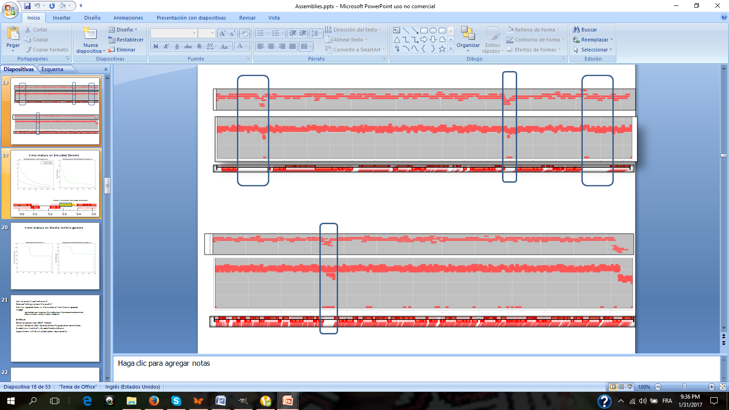

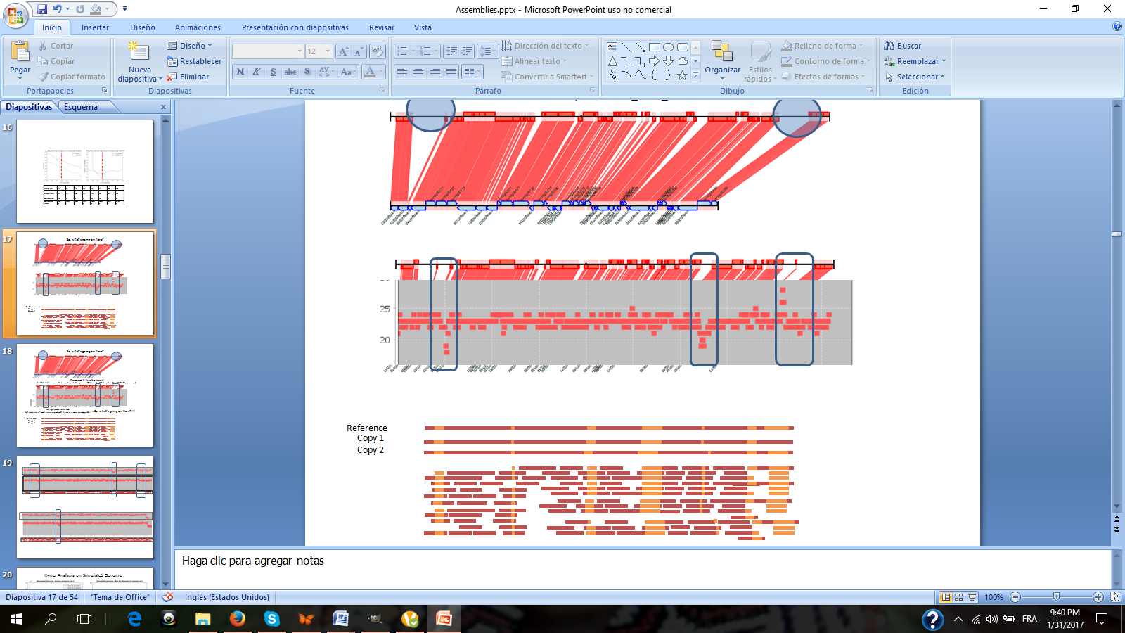

|  |  |  |  |  |  |  |  |  |
| --- | --- | --- | --- | --- | --- | --- | --- | --- |
| TOTAL SEQ LENGTH 316620 | | | | | | | | |
|  | WRONG over all chrom | % WRONG (all) | MISSED (all) | % MISSED (all) | WRONG IN SV | % WRONG IN SV | MISSED ON SV | % MISSED ON SV |
| 75 | 17074 | 5.39 | 326 | 0.10 | 5787 | 57.87 | 150 | 1.50 |
| 100 | 11850 | 3.74 | 550 | 0.17 | 3350 | 33.50 | 550 | 5.50 |
| 500 | 9500 | 3.00 | 620 | 0.20 | 1250 | 12.50 | 500 | 5.00 |
| 600 | 10500 | 3.32 | 1020 | 0.32 | 2300 | 23.00 | 300 | 3.00 |
| 750 | 750 | 0.24 | 745 | 0.24 | 750 | 7.50 | 0 | 0.00 |
| 1000 | 3000 | 0.95 | 500 | 0.16 | 3000 | 30.00 | 500 | 5.00 |
| 1500 | 10000 | 3.16 | 0 | 0.00 | 10000 | 100.00 | 0 | 0.00 |
| 2000 | 10000 | 3.16 | 0 | 0.00 | 10000 | 100.00 | 0 | 0.00 |
| 3000 | 10000 | 3.16 | 0 | 0.00 | 10000 | 100.00 | 0 | 0.00 |

# Using the allele frequencies to disambiguate the ploidy ratio.

**NOVOGENE_CBS1483**

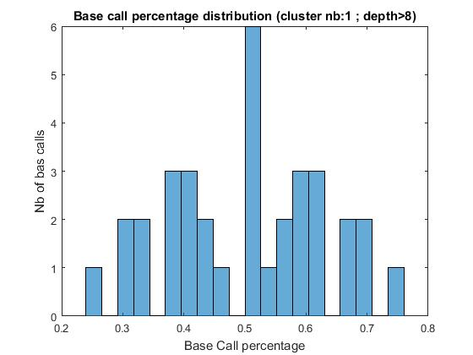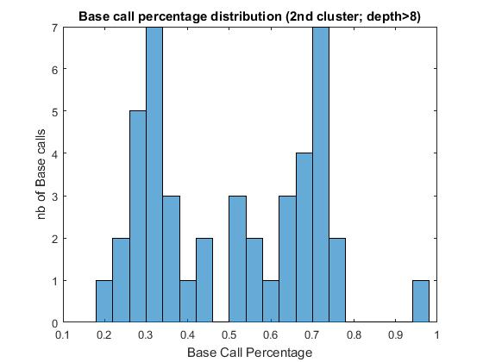

**SIMULATED GENOME**



**BASECLEAR_CBS1483**

# Results of the fit with very large window sizes.

**Simulated data**

Even with a very large window size Ploest fits correctly the main clusters of the read distribution. It is important to take into consideration that the original distribution of the simulated data has very clearly distinct clusters.



**Base Clear Genome**

The following plot shows the fit with a wl=75 Kbp. wl=100Kb is too big for any of the contigs in this genome to function, so we explored and reached the upper limit of the window size parameter successfully, even with real dataset.



# Ploidy estimation fragmentation per round for different window sizes.

|  |  |  |  |  |  |  |
| --- | --- | --- | --- | --- | --- | --- |
|  | P1 | # solved | BC | Nb Breaks | 1st round | 2nd round |
| 40 | 2 | 52 | 1 | 6769 | 6706 | 63 |
| 50 | 1 | 51 | 0 | 1402 | 1315 | 85 |
| 75 | 1 | 51 | 0 | 1062 | 1002 | 60 |
| 100 | 1 | 51 | 0 | 425 | 417 | 8 |
| 250 | 1 | 51 | 0 | 155 | 147 | 8 |
| 400 | 1 | 51 | 0 | 77 | 69 | 8 |
| 500 | 1 | 51 | 0 | 71 | 64 | 7 |
| 750 | 1 | 51 | 1 | 77 | 63 | 14 |
| 1000 | 1 | 51 | 0 | 73 | 54 | 19 |
| 1500 | 1 | 51 | 0 | 88 | 50 | 38 |
| 2000 | 1 | 51 | 0 | 102 | 48 | 54 |
| 2500 | 1 | 51 | 0 | 97 | 46 | 51 |
| 3000 | 1 | 51 | 0 | 93 | 47 | 46 |
| 3500 | 1 | 51 | 0 | 89 | 35 | 54 |
| 5000 | 1 | 51 | 0 | 167 | 44 | 123 |
| 5500 | 1 | 51 | 1 | 187 | 41 | 146 |
| 6000 | … | … | … | … | … | ... |
| 7500 | 1 | 51 | 0 | 448 | 39 | 409 |
| 9000 | 1 | 51 | 1 | 299 | 37 | 262 |
| 10000 | 1 | 51 | 1 | 320 | 35 | 285 |
| 15000 | 1 | 51 | 1 | 636 | 30 | 606 |
| 20000 | 2 | 51 | 1 | 758 | 27 | 731 |
| 30000 | 1 | 51 | 1 | 1510 | 22 | 1488 |
| 40000 | 1 | 50 | 1 | 4079 | 15 | 4064 |
| 50000 | 1 | 50 | 1 | 6028 | 4 | 6024 |
| 75000 | 2 | 47 | 1 | 6956 | 1 | 6955 |

# Coverage/ploidy plots for the 8 common unsolved contigs in Baseclear CBS1483 *wl* = 1000 bp



Contig 51 (989 Kbp) Contig41 (73 Kbp) and both have a very irregular coverage information to make a reliable estimation



Contig 46 (3291 bp) and Contig 48 (2346 bp) both have a very irregular coverage information to make a reliable estimation



Contig 52 (953 bp) and Contig 54 (762 bp) both have a very irregular coverage information to make a reliable estimation



# Full ploidy estimation for Baseclear CBS1483 from selected window sizes (2Kb,1Kb,750,500,400 and 16bp)

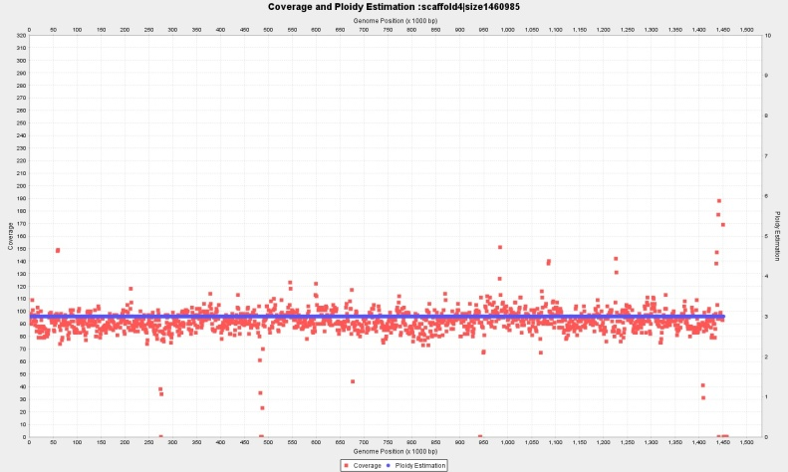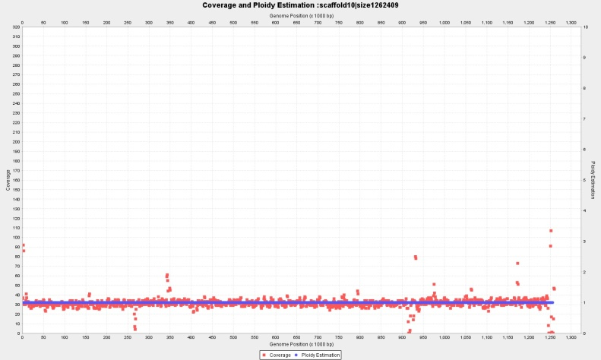

Contig 4 (1460Kbp) wl=2.000 bp, with continuous p=3 and Contig 10 (1262Kbp) wl=2.000 bp, with constant copy number p=1

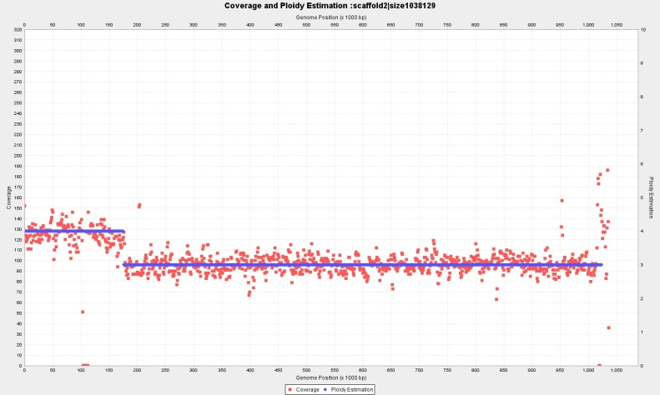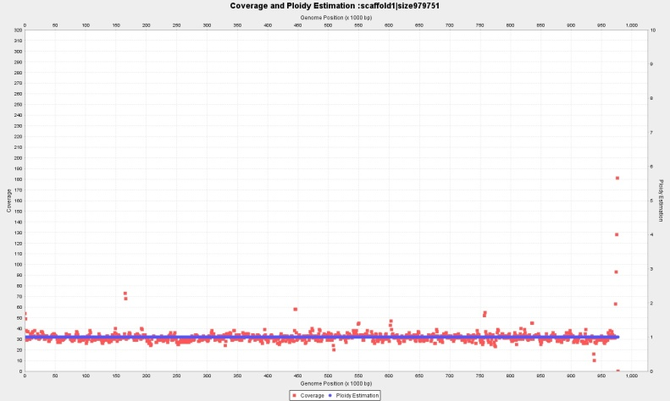

Contig 2 (1038Kbp) wl=2.000 p={4,3,4} and Contig 1 (979 Kbp) wl=2.000 p=1

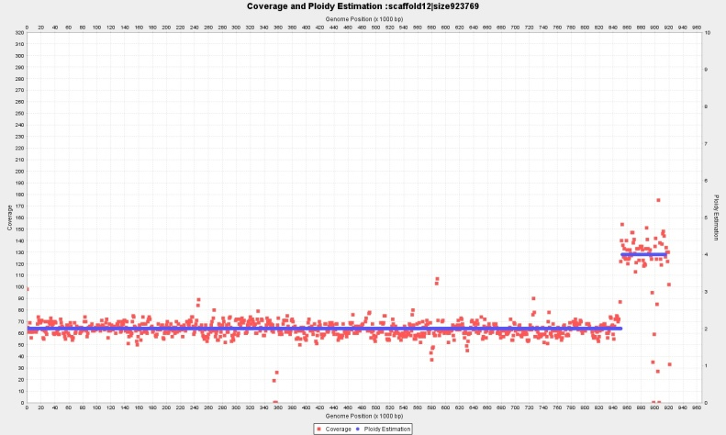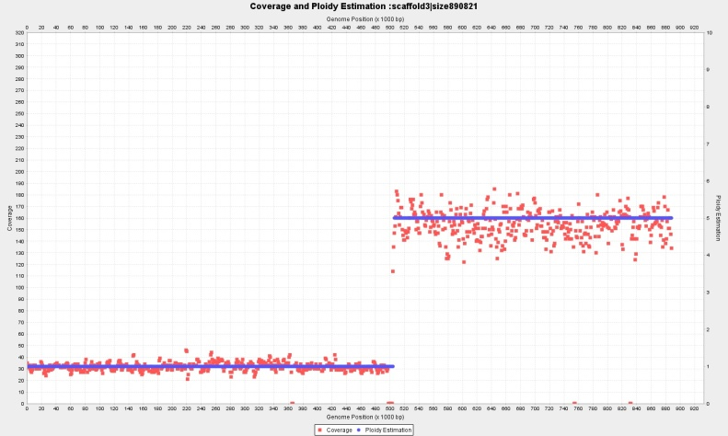

Contig 12 (923 Kbp) wl=2.000 bp, p={2,4} and Contig 3 (890 Kbp) wl=2.000 bp, p={1,5}

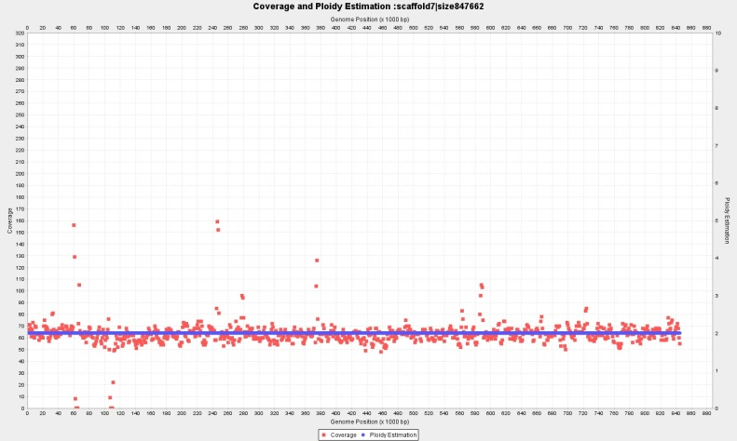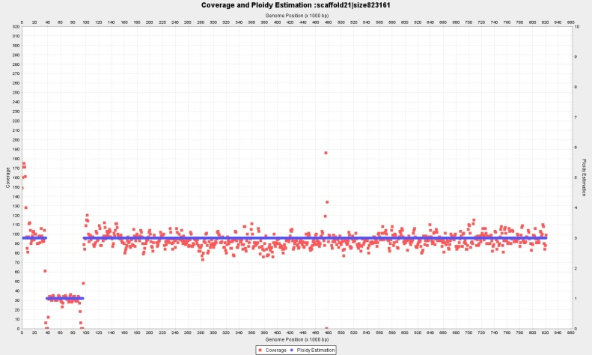

Contig 7 (847 Kbp) wl=2.000 bp, p={2} and Contig 21 (823 Kbp) wl=2.000 bp, with fragmented copy numbers P={3,1,3}

**Complete ploidy estimation for Baseclear CBS1483**

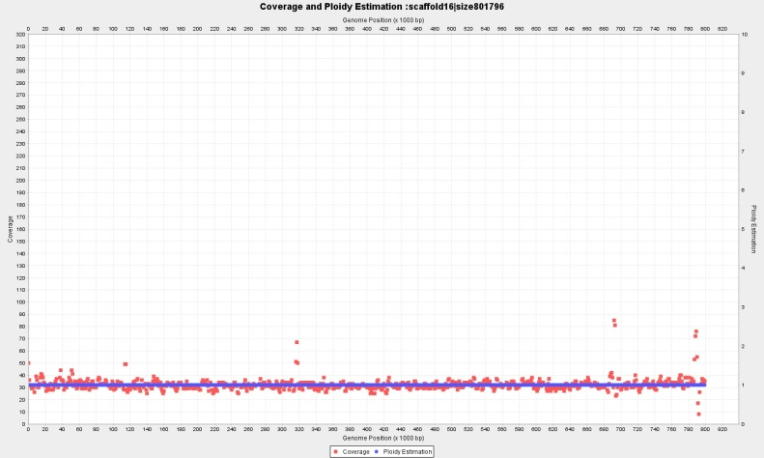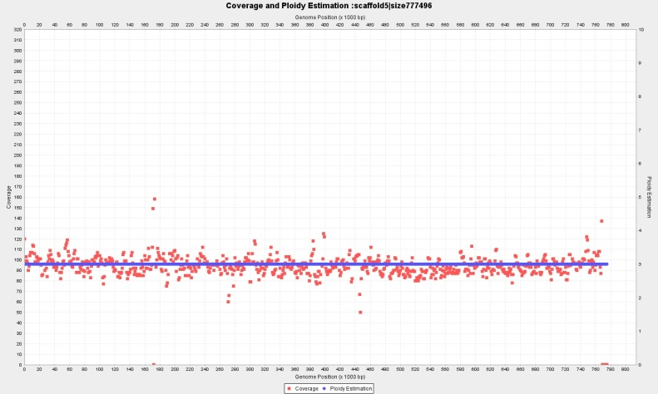

Contig 16 (801 Kbp) wl=2.000 bp, p=1 and Contig 5 (777 Kbp) wl=2.000 bp, with p=3

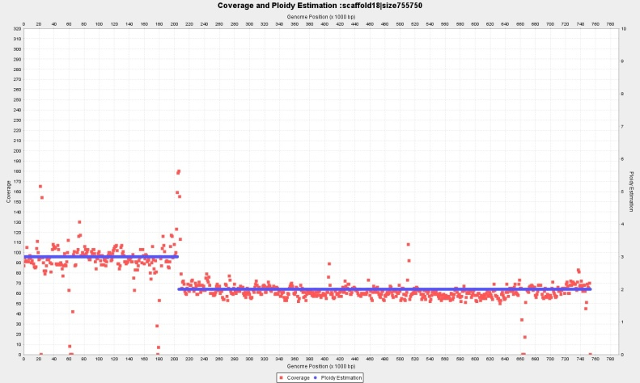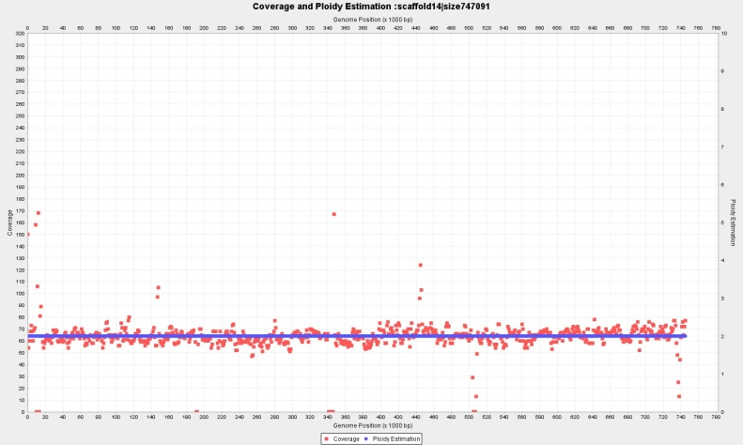

Contig18 (755 Kbp) wl=2.000 bp, P={3,2} and Contig 14 (747 Kbp) wl=2.000 bp, with p=2

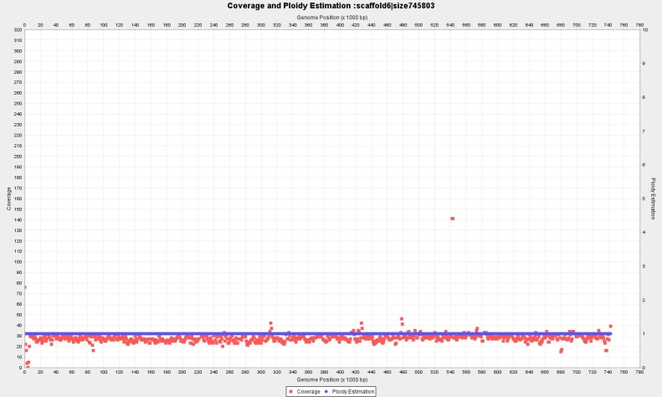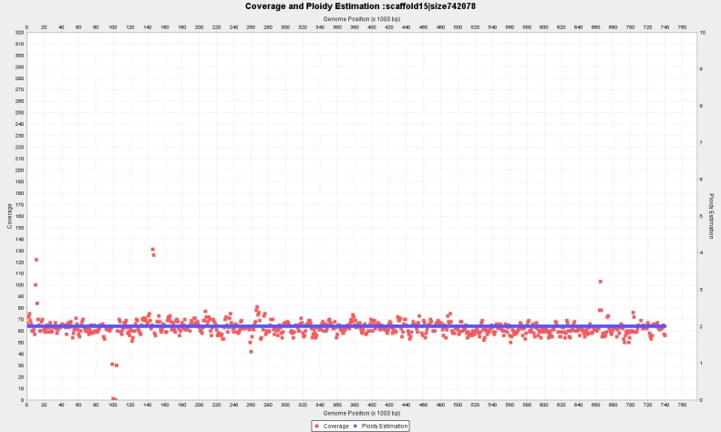

Contig 6 (745 Kbp) p=1 wl=2.000 and Contig 15 (742 Kbp) wl=2.000 with p=2

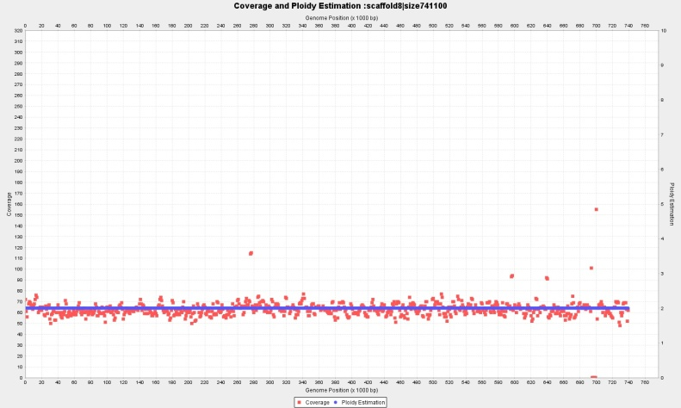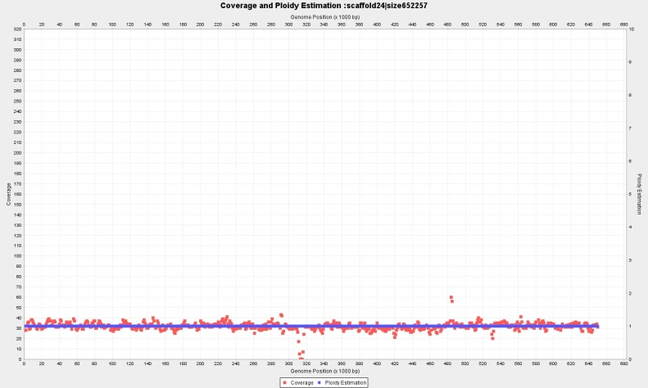

Contig 8 (741 Kbp) wl=2.000 bp, p=2 and Contig 24 (652 Kbp) wl=2.000 bp, with p=1

**Complete ploidy estimation for Baseclear CBS1483**

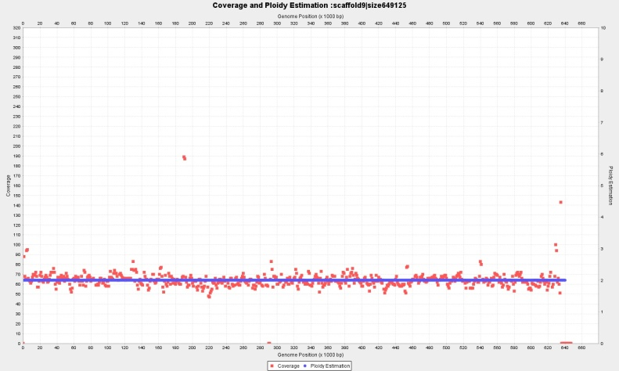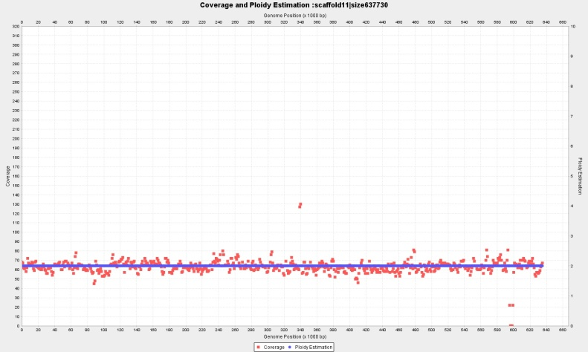

Contig 9 (649 Kbp) wl=2.000 bp, p=2 and Contig 11 (637 Kbp) wl=2.000 bp, with p=2

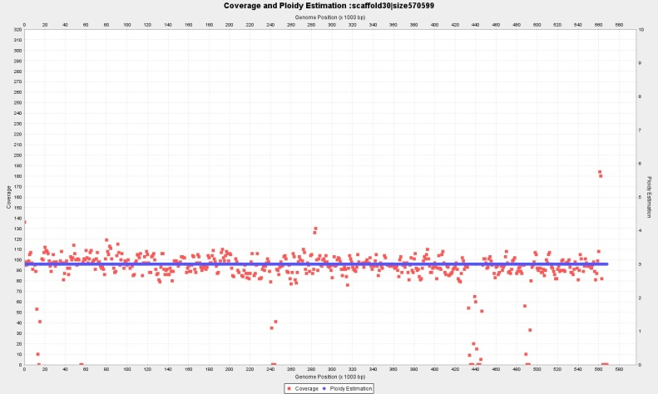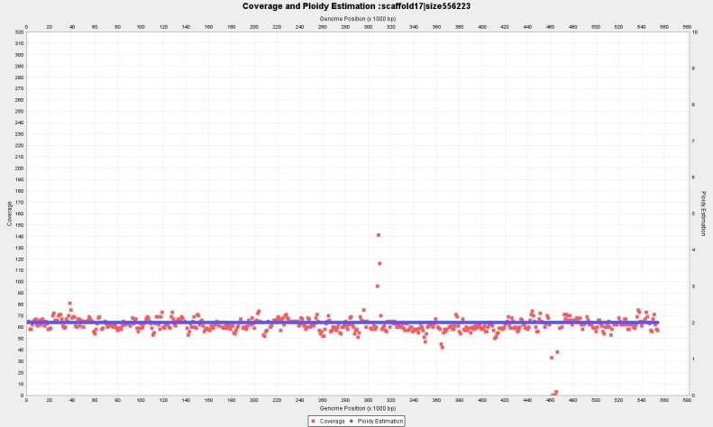

Contig 30 (570 Kbp) wl=2.000 bp, p=3 and Contig 17 (556 Kbp) wl=2.000 bp, with p=2

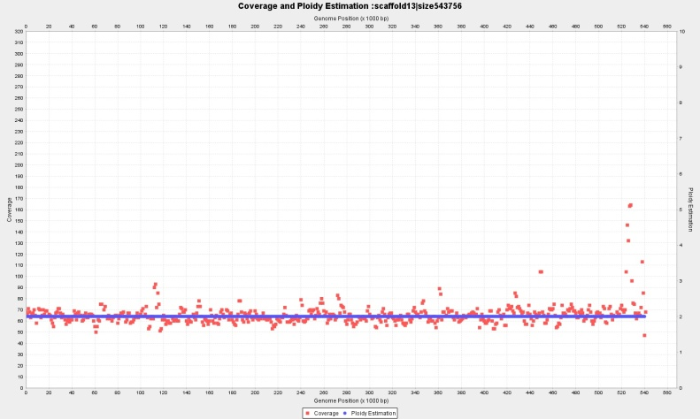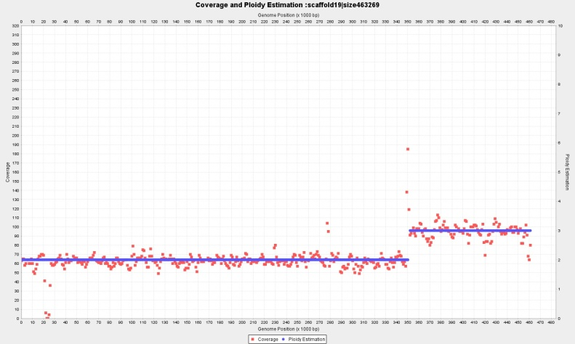

Contig 13 (543 Kbp) wl=2.000 bp, p=2 and Contig 19 (463 Kbp) wl=2.000 bp, with P={2,3}

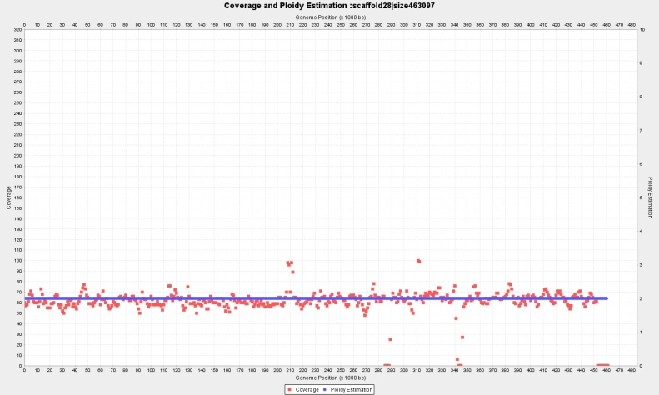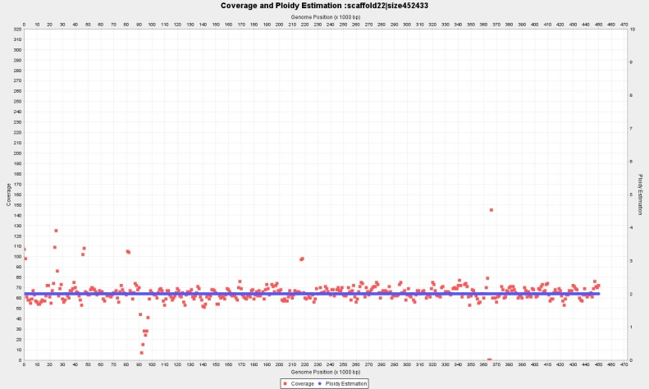

Contig 28 (463 Kbp) wl=2.000 bp, p=2 and Contig 22 (452 Kbp) wl=2.000 bp, with p=2

**Complete ploidy estimation for Baseclear CBS1483**

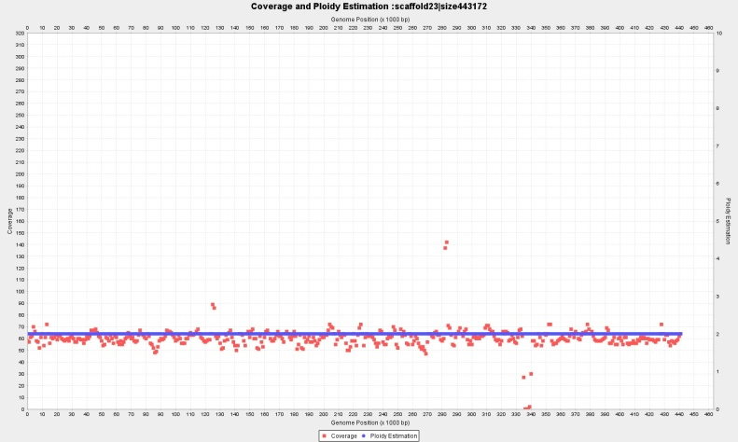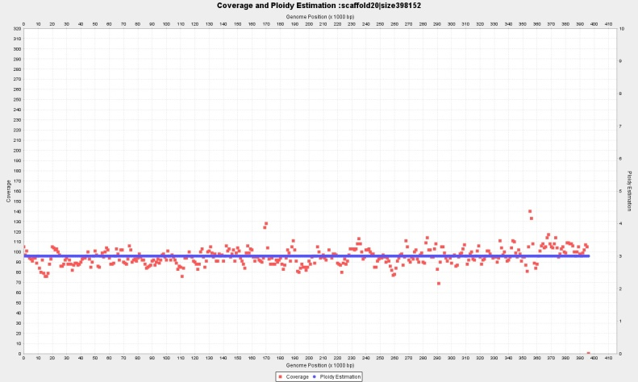

Contig 23 (443 Kbp) wl=2.000 bp, p=2 and Contig 20 (398 Kbp) wl=2.000 bp, with p=3

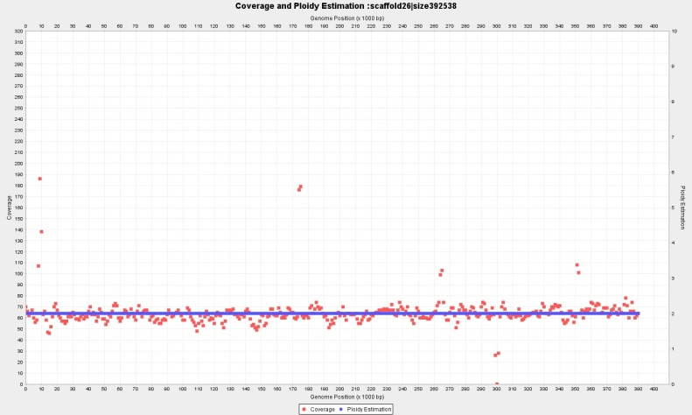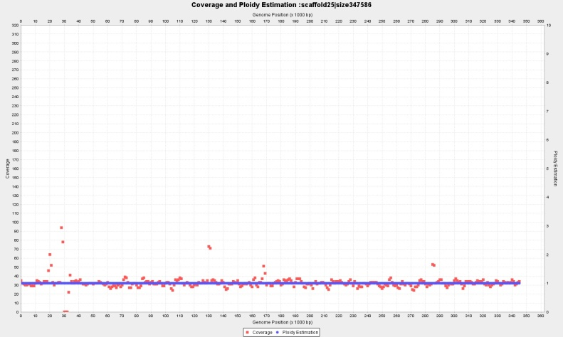

Contig 26 (463 Kbp) wl=2.000 bp, p=2 and Contig 25 (398 Kbp) wl=2.000 bp, with p=1

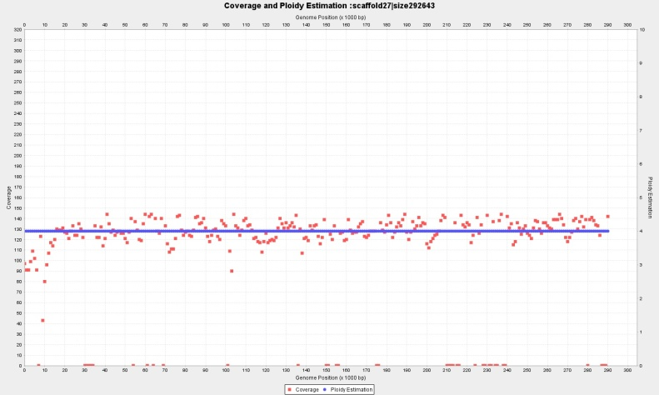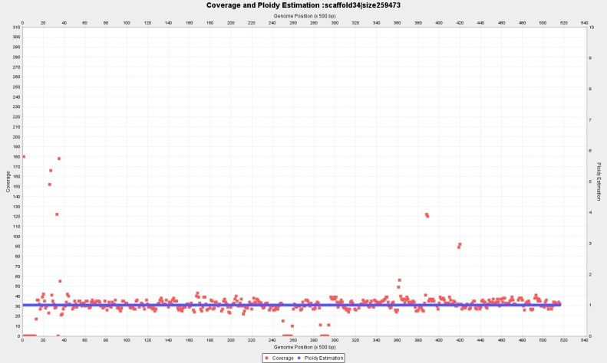

Contig 27 (292 Kbp) wl=2.000 bp, P={4} and Contig 34 (252 Kbp) wl=1.000 bp, with p=1

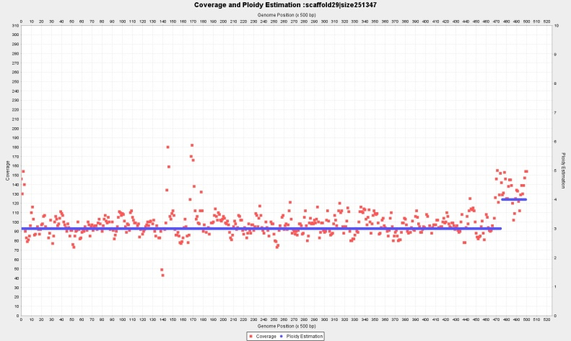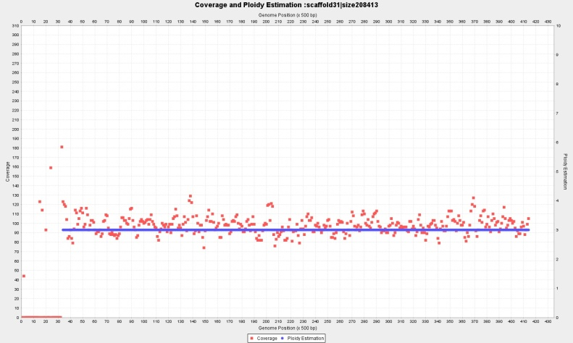

Contig 29 (251 Kbp) wl=1.000 bp, P={3,4} and Contig 31 (208 Kbp) wl=1.000 bp, with p=3

**Complete ploidy estimation for Baseclear CBS1483**

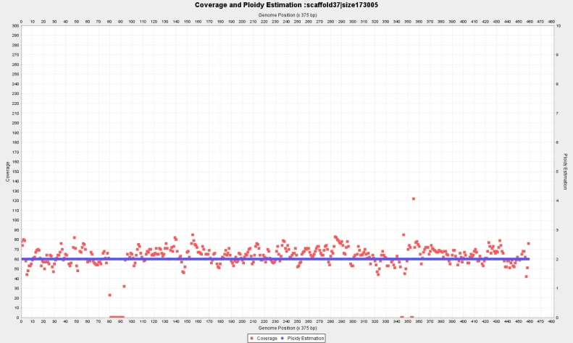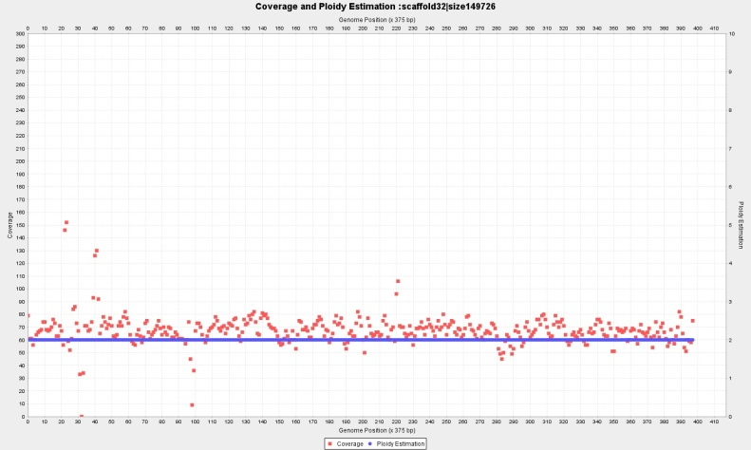

Contig 37 (173 Kbp) wl=750 bp, p=2; and Contig 32 (149 Kbp) wl=750 bp, with p=2

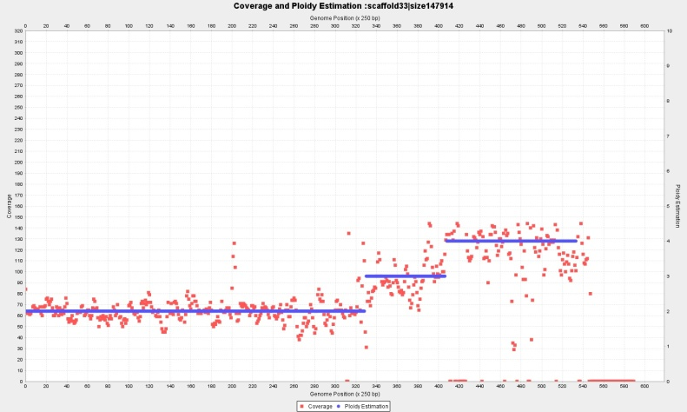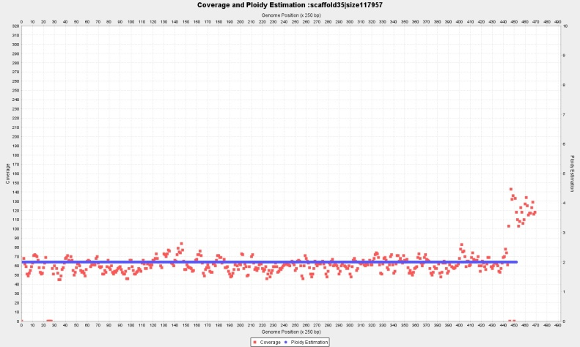

Contig 33 (147 Kbp) wl=500 bp, P={2,3,4} and Contig 35 (117 Kbp) wl=500 bp, with p=2

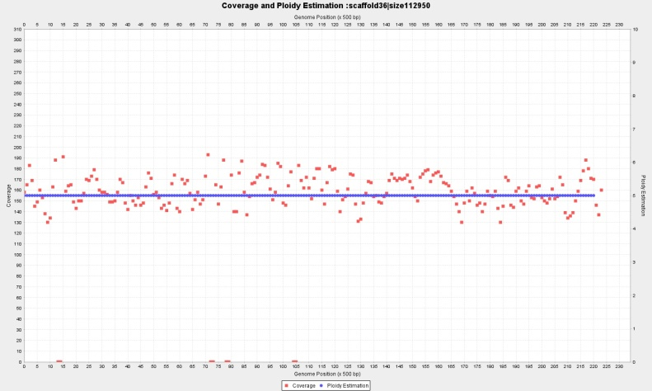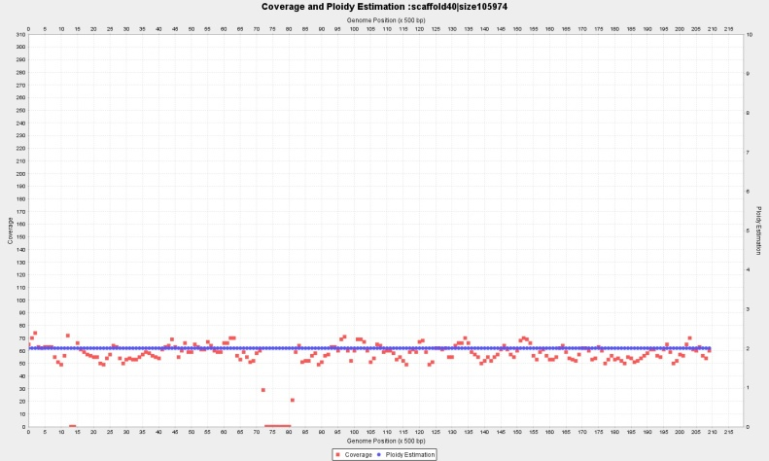

Contig 36 (112 Kbp) wl=1.000 bp, p=5 and Contig 40 (105 Kbp) wl=1.000 bp, with p=2

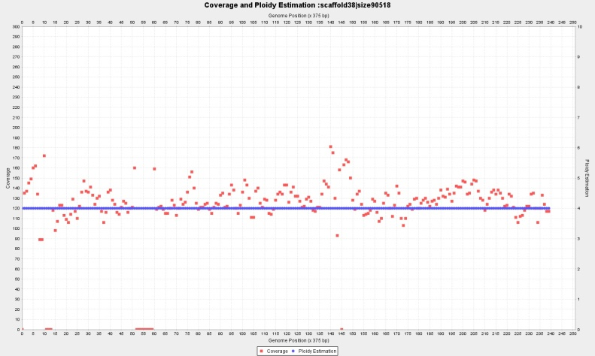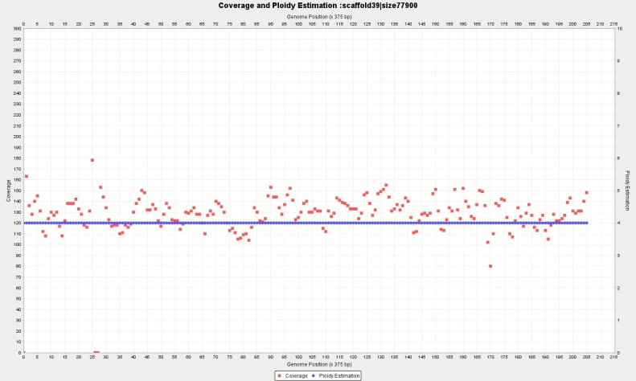

Contig 38 (90 Kbp) wl=750 bp, p=4 and Contig 39 (77 Kbp) wl=750 bp, with p=4,

**Complete ploidy estimation for Baseclear CBS1483**

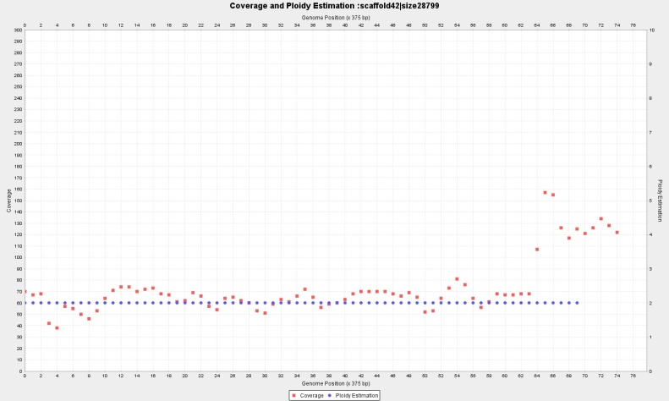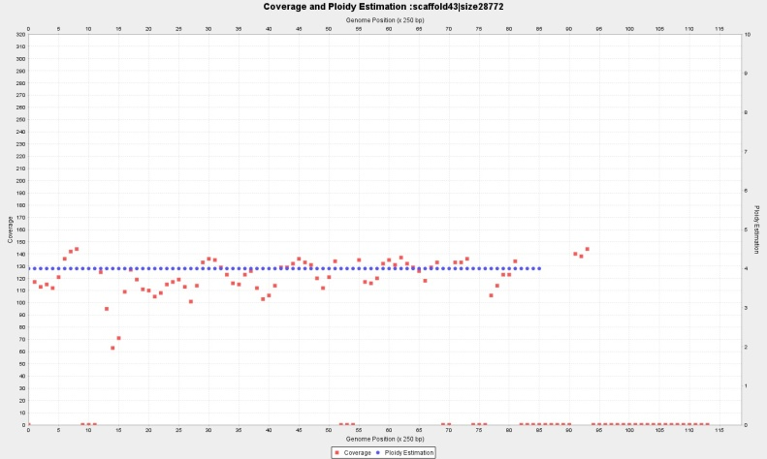

Contig 42 (28.7 Kbp) wl=750 bp, with p=2; and Contig 43 (28.7 Kbp) p=4, wl=500

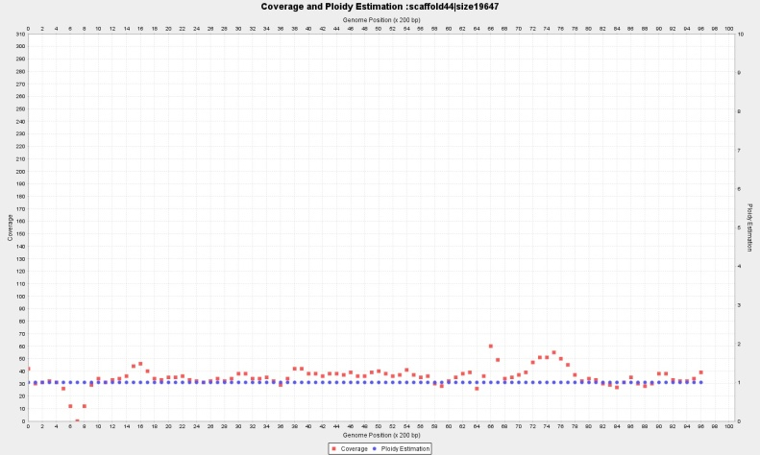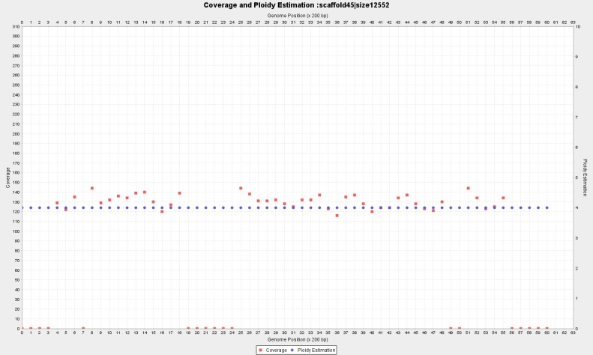

Contig 44 (19.6 Kbp) with p=1, wl=400 and Contig 45 (12.5 Kbp) p=4, wl=400

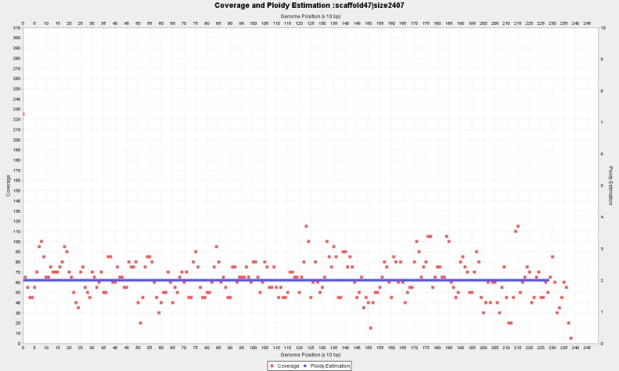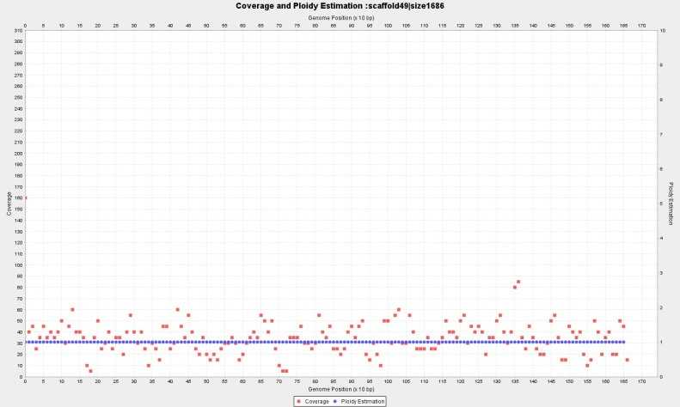

Contig 47 (2.407 bp) wl=20 with p=2, and Contig 49 (1.686 bp) wl=20, p=1,

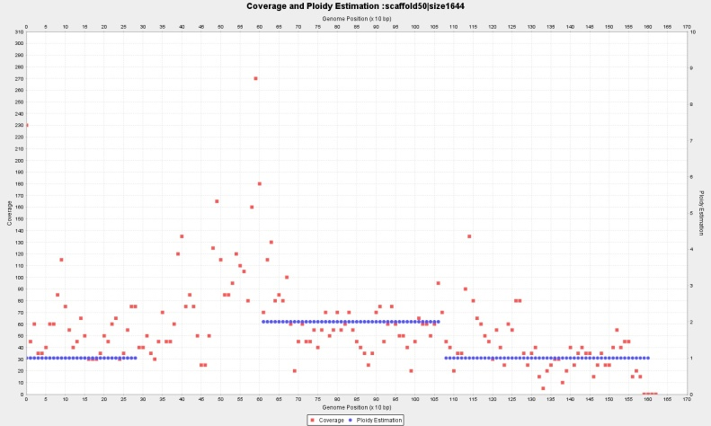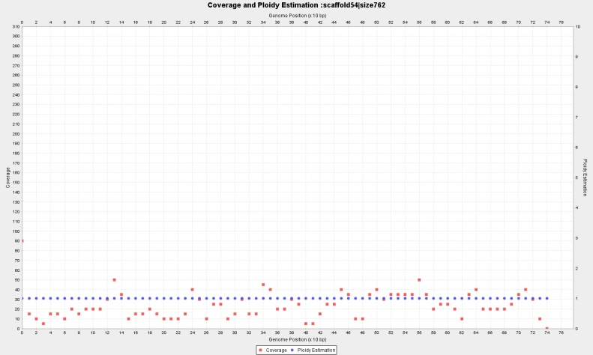

Contig 50 (1.644 bp) wl=20, with P={2?,**1?**} and Contig 54 (762 bp) wl=20, p=1

**Complete ploidy estimation for Baseclear CBS1483**

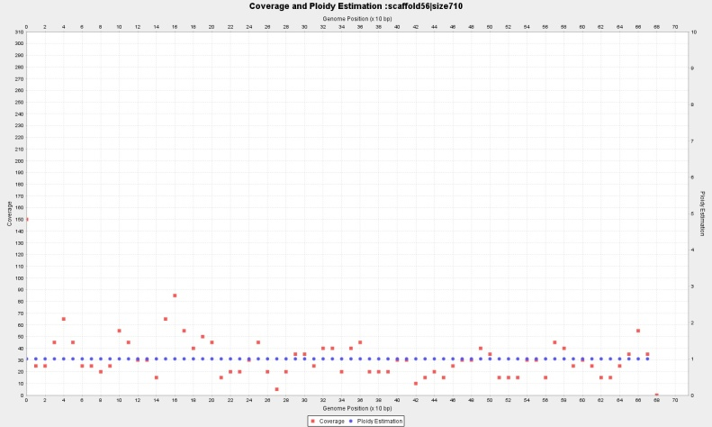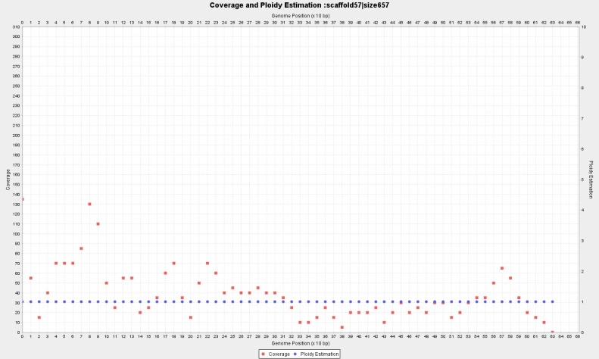

Contig 56 (710 bp) wl=16, with p=1 and Contig 57 (657 bp) wl=16, p=1

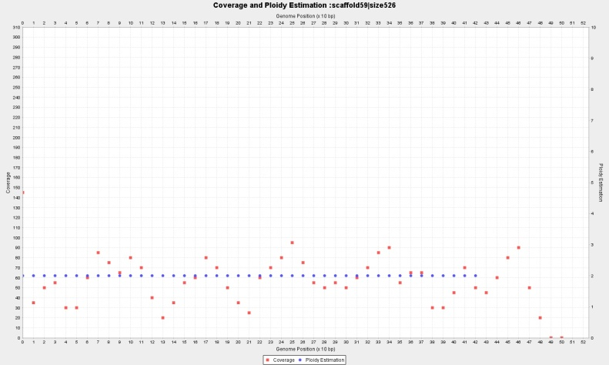

Contig 59 (526 bp) wl=16, p=2

# Full ploidy estimation for Novogene CBS1483 from selected window sizes (2Kb,1Kb,750,500,400 and 16bp)

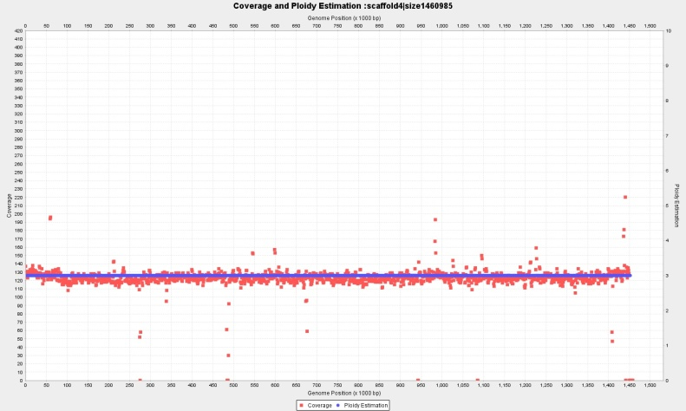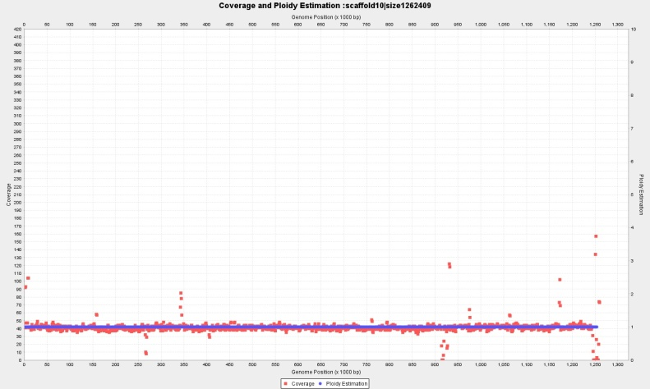

Contig 4 (1460Kbp) wl=2.000 bp, with continuous p=3 and Contig 10 (1262Kbp) wl=2.000 bp, with constant copy number p=1

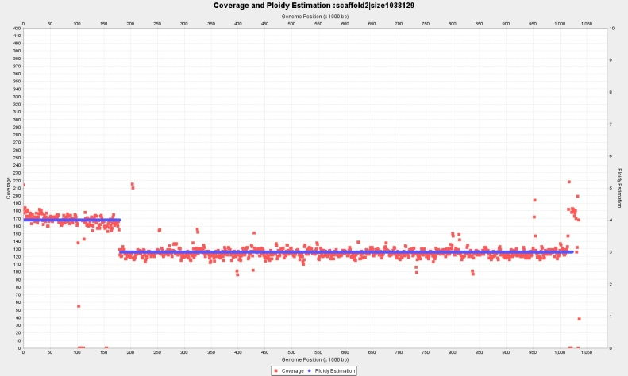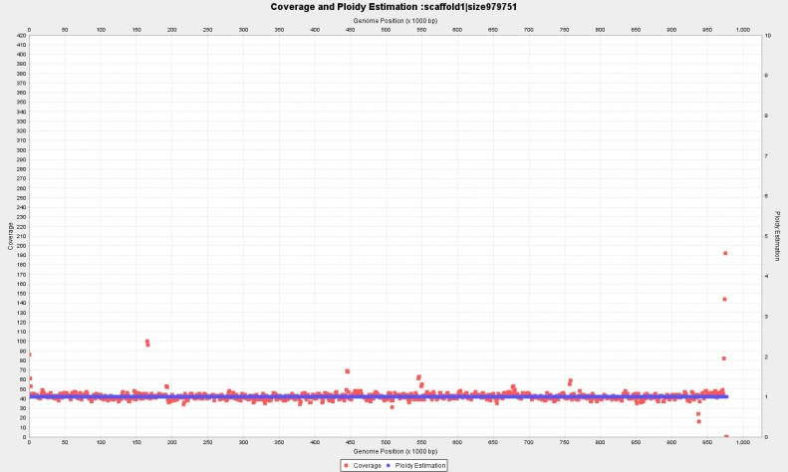

Contig 2 (1038Kbp) wl=2.000 p={4,3} and Contig 1 (979 Kbp) wl=2.000 p=1

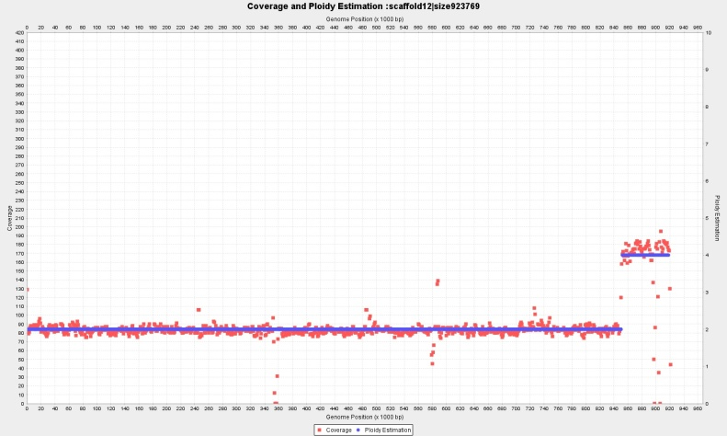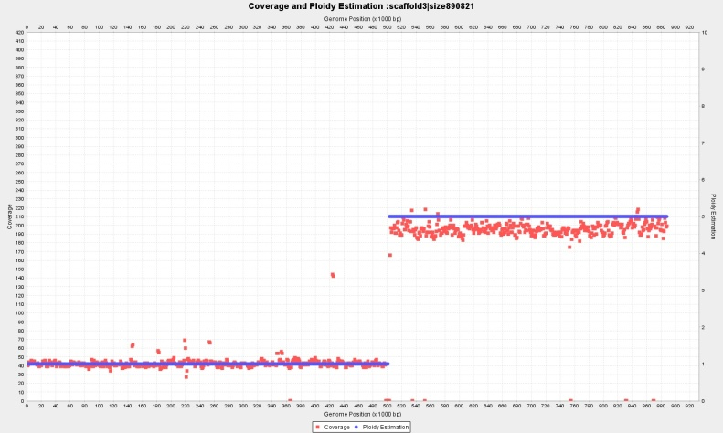

Contig 12 (923 Kbp) wl=2.000 bp, p={2,4} and Contig 3 (890 Kbp) wl=2.000 bp, p={1,5}

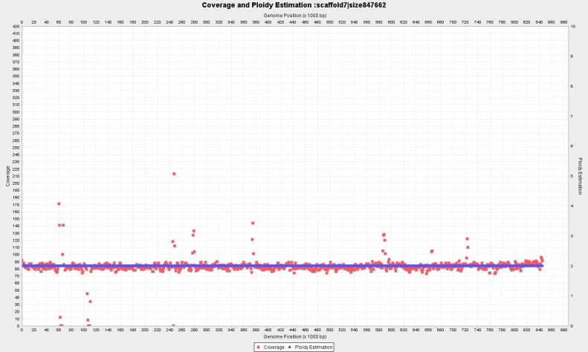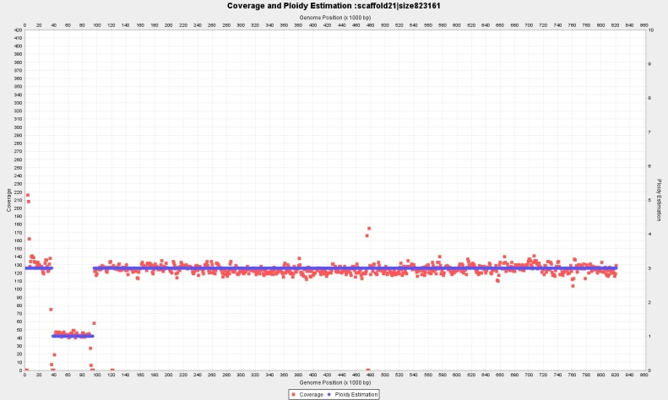

Contig 7 (847 Kbp) wl=2.000 bp, p={2} and Contig 21 (823 Kbp) wl=2.000 bp, with fragmented copy numbers P={3,1,3}

**Complete ploidy estimation for Novogene CBS1483**

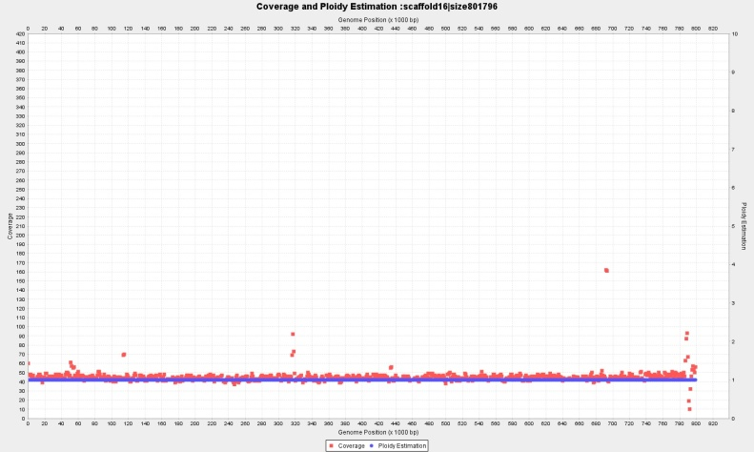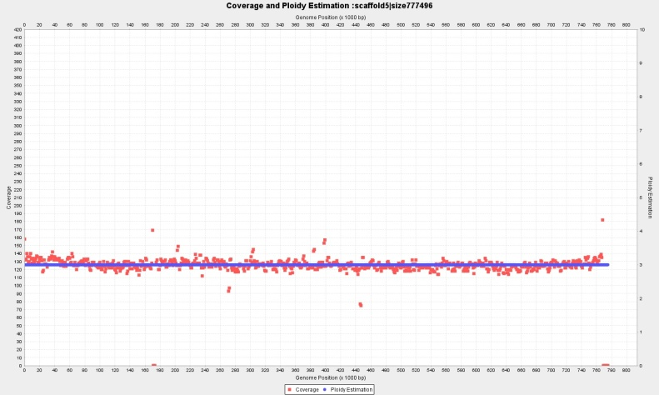

Contig 16 (801 Kbp) wl=2.000 bp, p=1 and Contig 5 (777 Kbp) wl=2.000 bp, with p=3

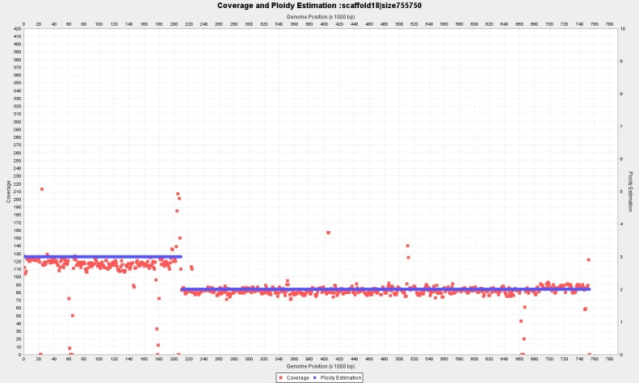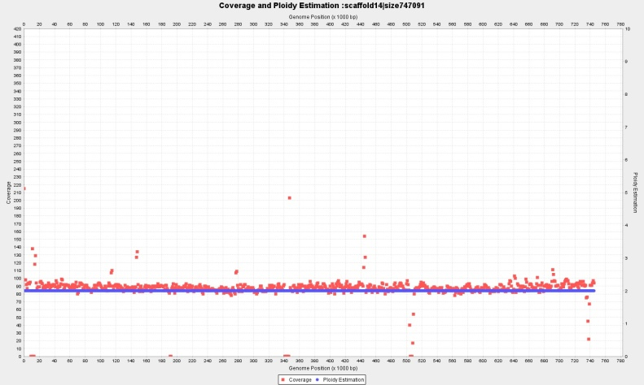

Contig18 (755 Kbp) wl=2.000 bp, P={3,2} and Contig 14 (747 Kbp) wl=2.000 bp, with p=2

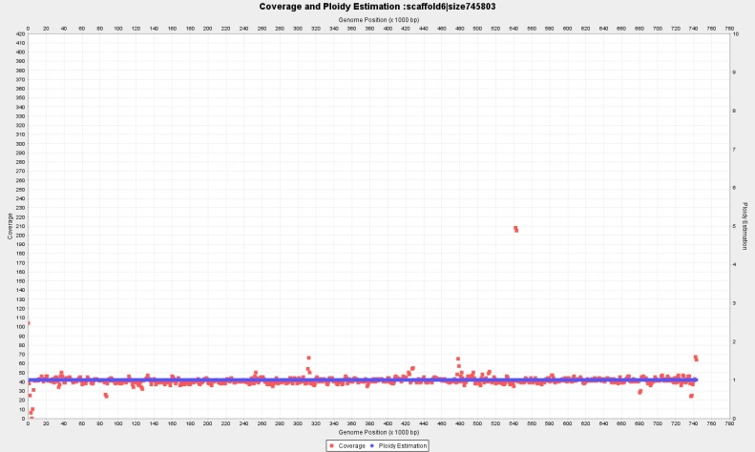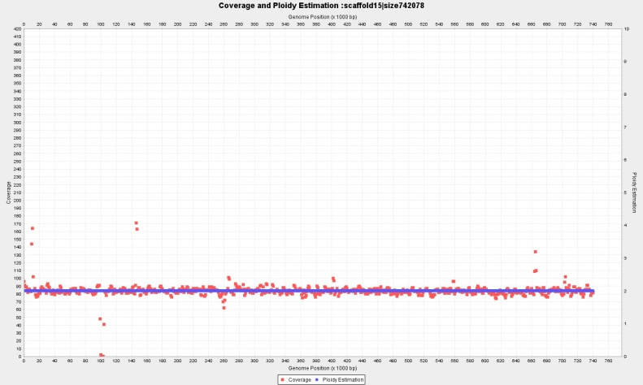

Contig 6 (745 Kbp) p=1 wl=2.000 and Contig 15 (742 Kbp) wl=2.000 with p=2

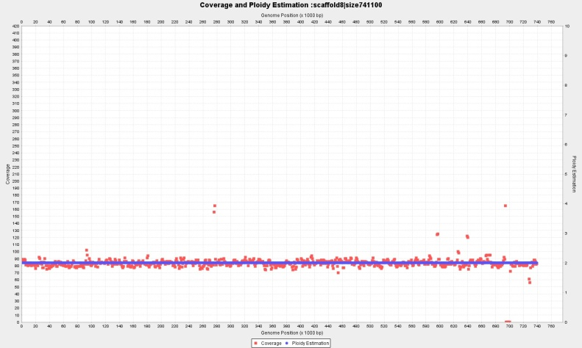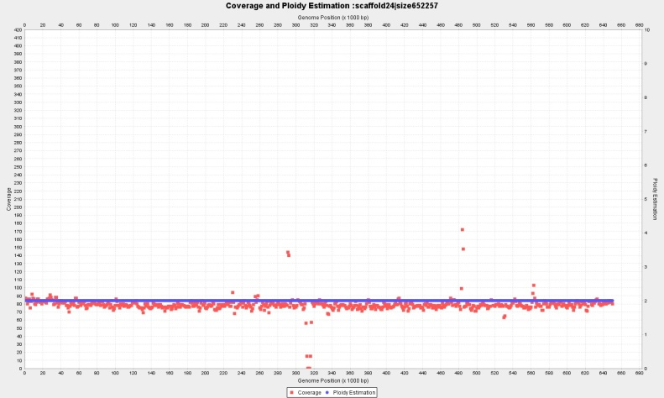

Contig 8 (741 Kbp) wl=2.000 bp, p=2 and Contig 24 (652 Kbp) wl=2.000 bp, with **p=2!!**

**Complete ploidy estimation for Novogene CBS1483**

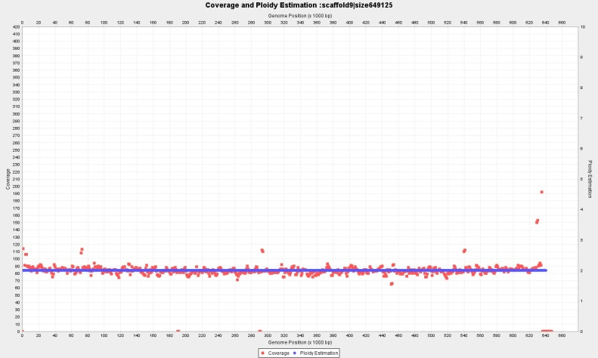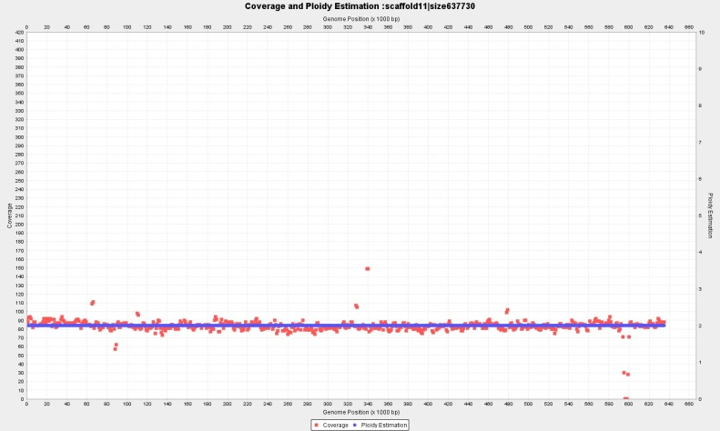

Contig 9 (649 Kbp) wl=2.000 bp, p=2 and Contig 11 (637 Kbp) wl=2.000 bp, with p=2

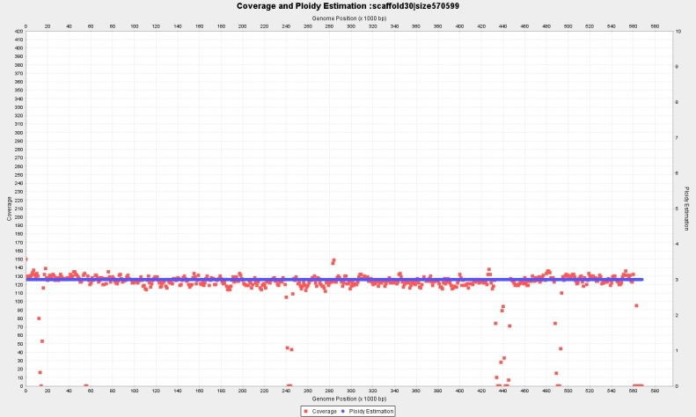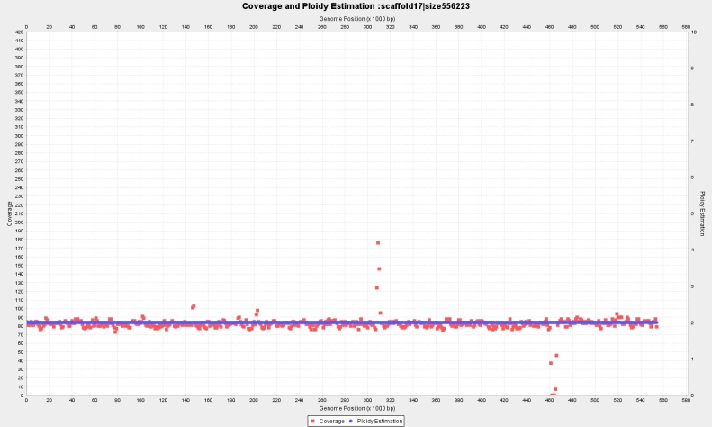

Contig 30 (570 Kbp) wl=2.000 bp, p=3 and Contig 17 (556 Kbp) wl=2.000 bp, with p=2

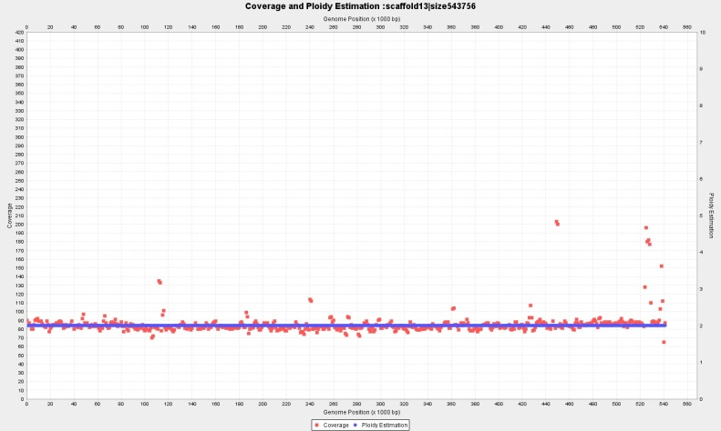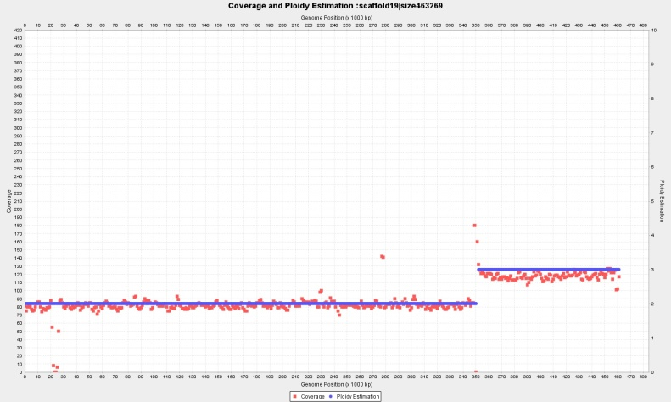

Contig 13 (543 Kbp) wl=2.000 bp, p=2 and Contig 19 (463 Kbp) wl=2.000 bp, with P={2,3}

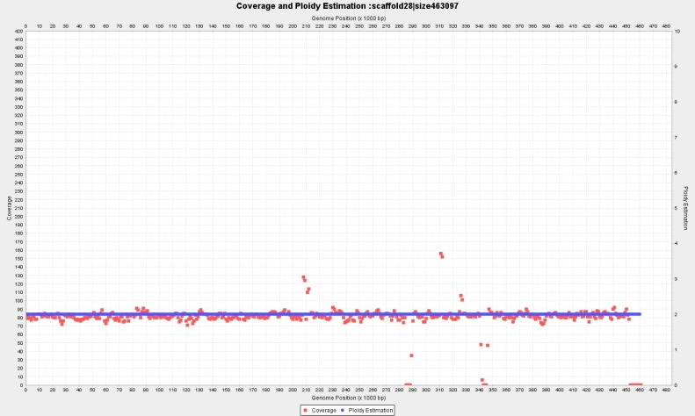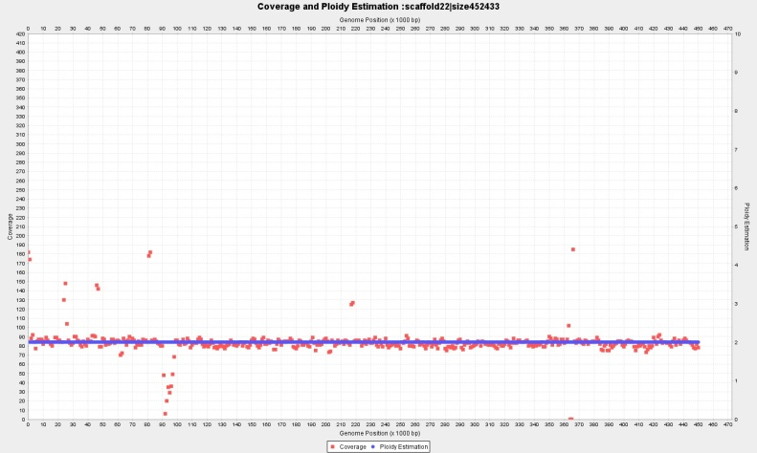

Contig 28 (463 Kbp) wl=2.000 bp, p=2 and Contig 22 (452 Kbp) wl=2.000 bp, with p=2

**Complete ploidy estimation for Novogene CBS1483**

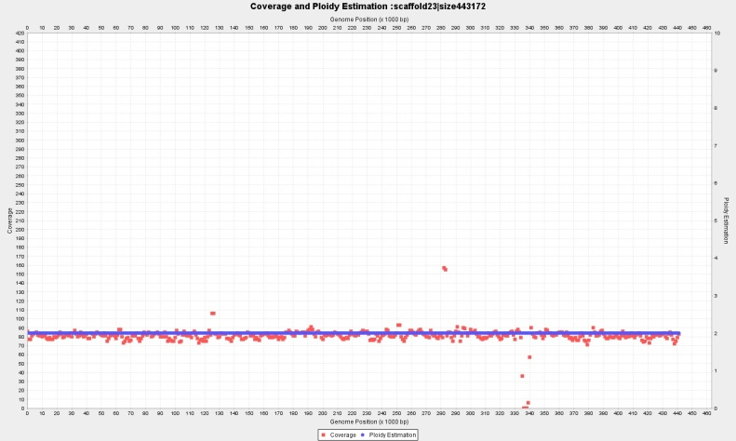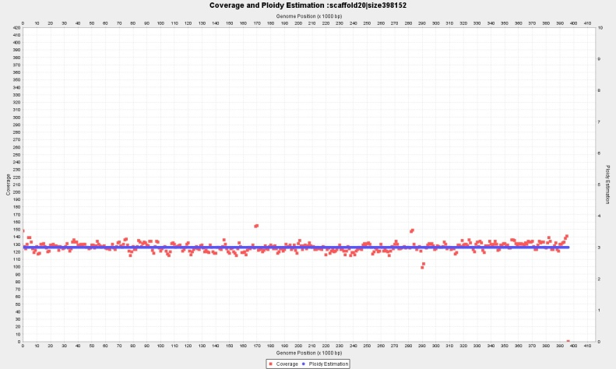

Contig 23 (443 Kbp) wl=2.000 bp, p=2 and Contig 20 (398 Kbp) wl=2.000 bp, with p=3

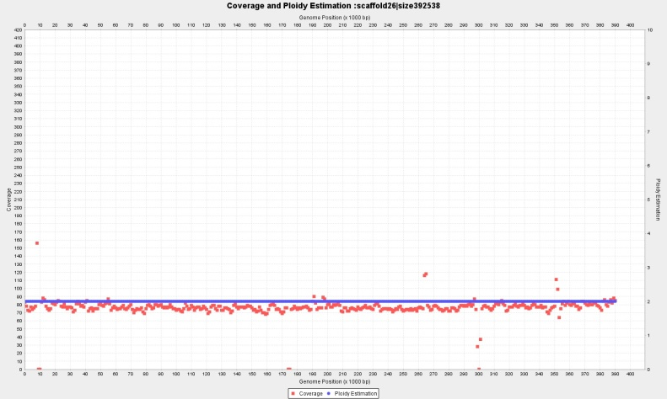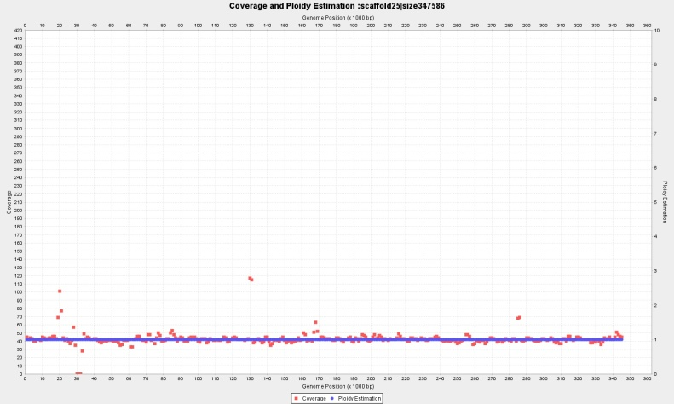

Contig 26 (463 Kbp) wl=2.000 bp, p=2 and Contig 25 (398 Kbp) wl=2.000 bp, with p=1

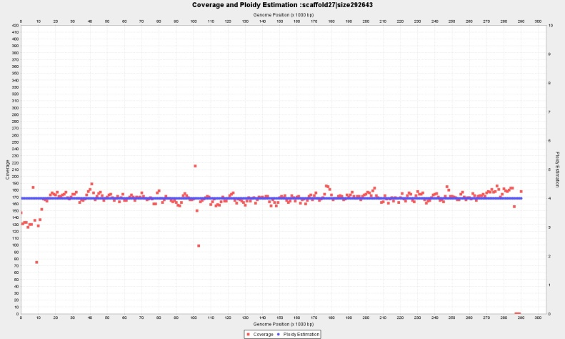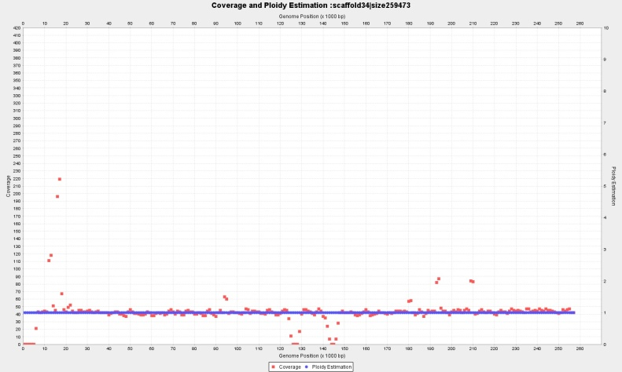

Contig 27 (292 Kbp) wl=2.000 bp, P={} and Contig 34 (252 Kbp) wl=1.000 bp, with p=1

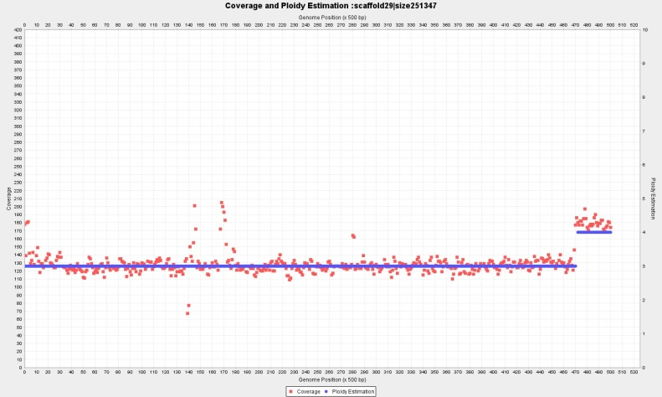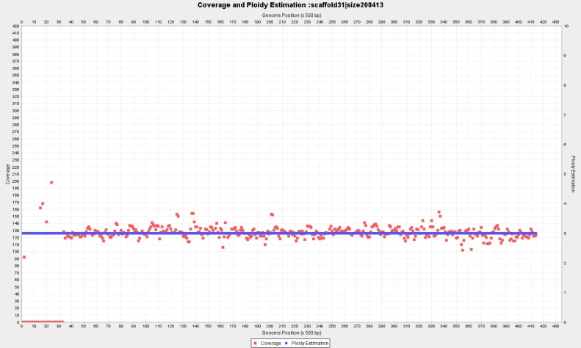

Contig 29 (251 Kbp) wl=1.000 bp, P={3,4} and Contig 31 (208 Kbp) wl=1.000 bp, with p=3

**Complete ploidy estimation for Novogene CBS1483**

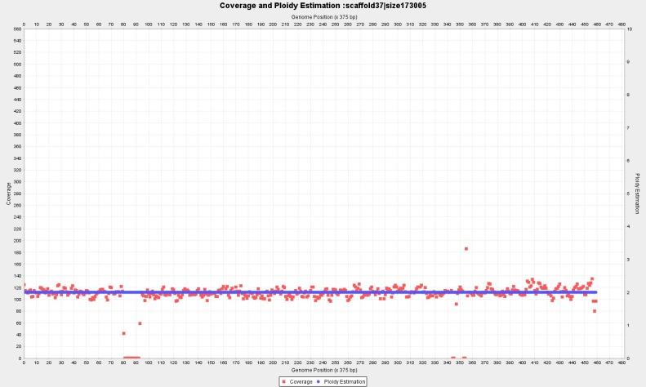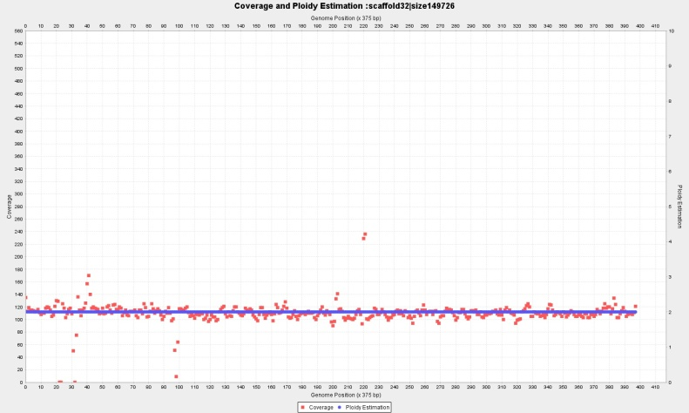

Contig 37 (173 Kbp) wl=750 bp, p=2; and Contig 32 (149 Kbp) wl=750 bp, with p=2

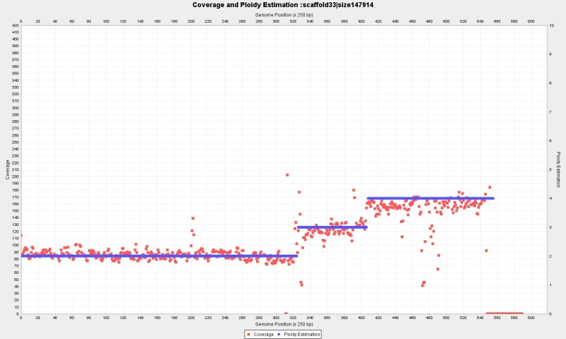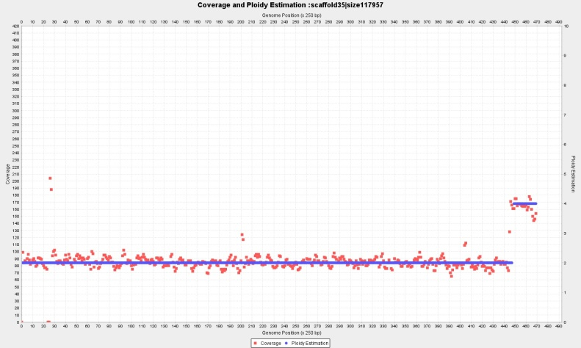

Contig 33 (147 Kbp) wl=500 bp, P={2,3,4} and Contig 35 (117 Kbp) wl=500 bp, with p={2,4}

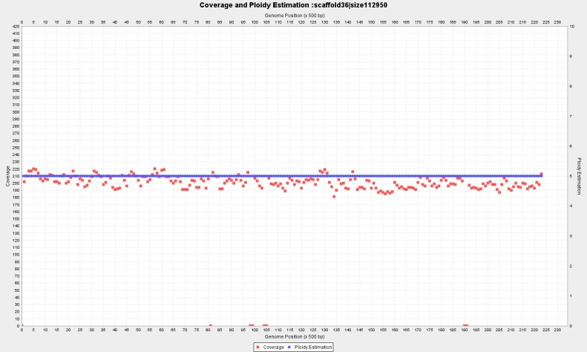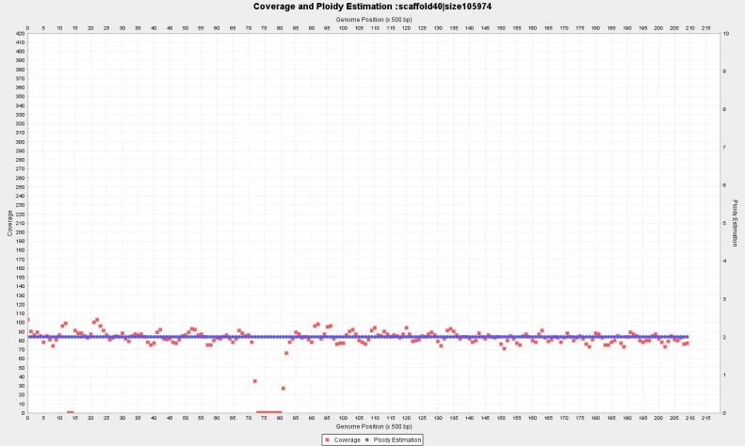

Contig 36 (112 Kbp) wl=1.000 bp, p=5 and Contig 40 (105 Kbp) wl=1.000 bp, with p=2

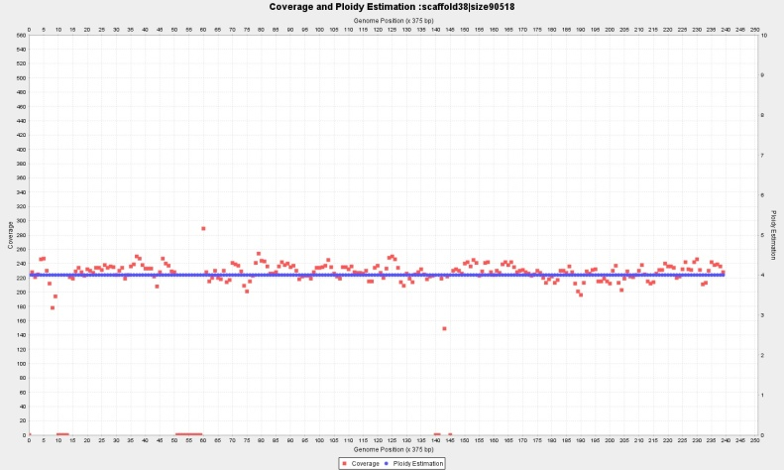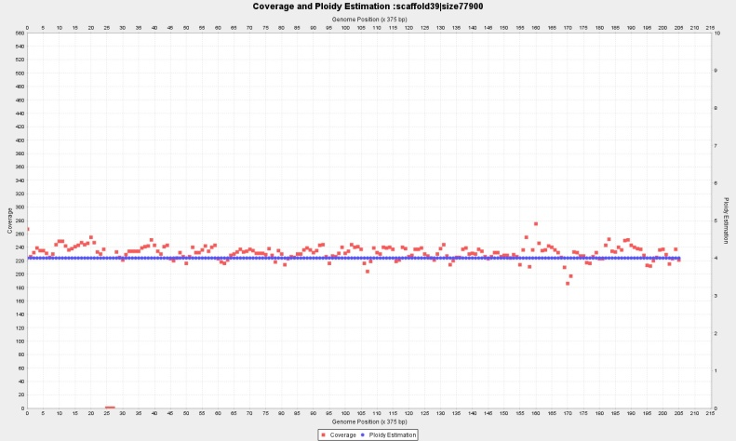

Contig 38 (90 Kbp) wl=750 bp, p=4 and Contig 39 (77 Kbp) wl=750 bp, with p=4,

**Complete ploidy estimation for Novogene CBS1483**

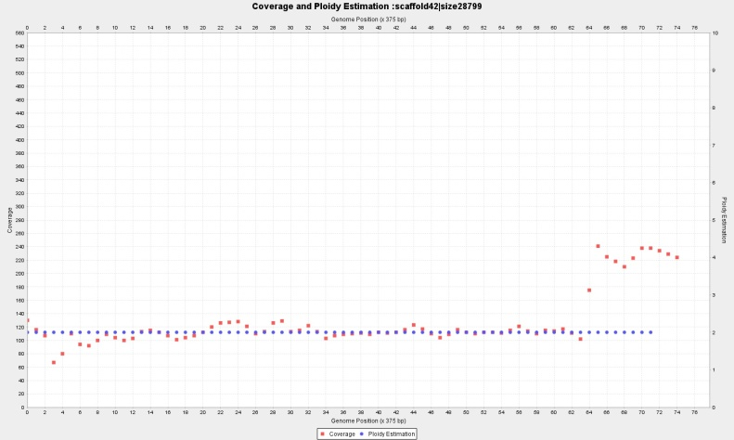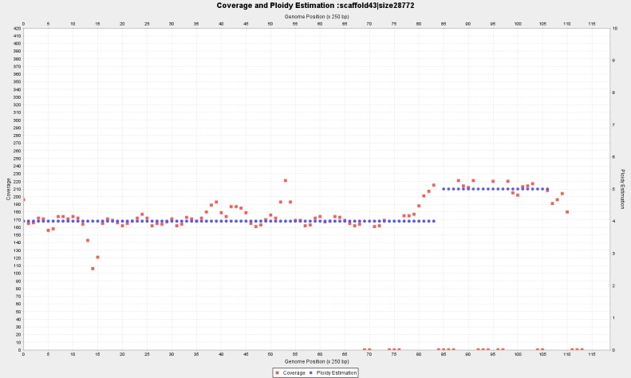

Contig 42 (28.7 Kbp) wl=750 bp, with p=2; and Contig 43 (28.7 Kbp) p=4, wl=500

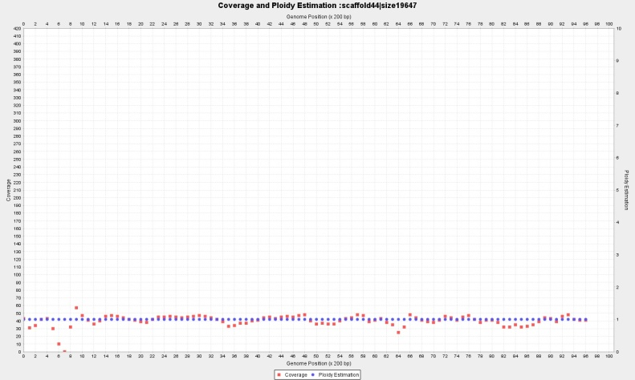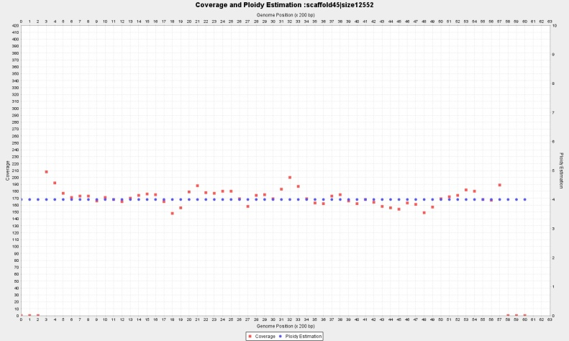

Contig 44 (19.6 Kbp) with p=1, wl=400 and Contig 45 (12.5 Kbp) p=4, wl=400

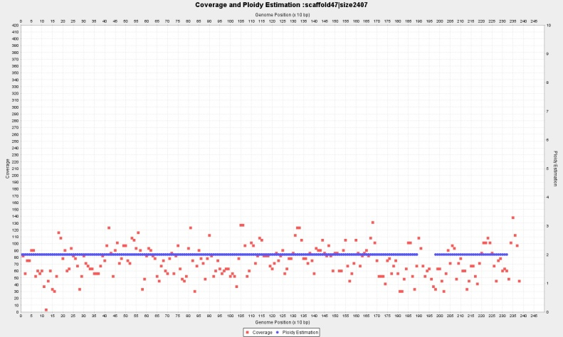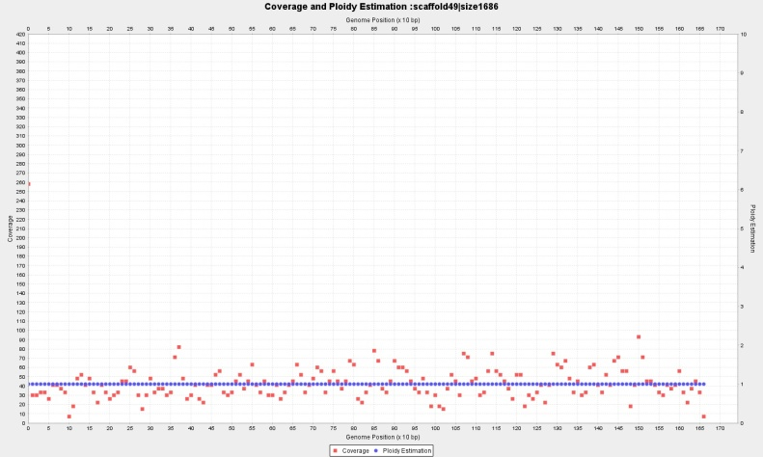

Contig 47 (2.407 bp) wl=20 with p=2, and Contig 49 (1.686 bp) wl=20, p=1,

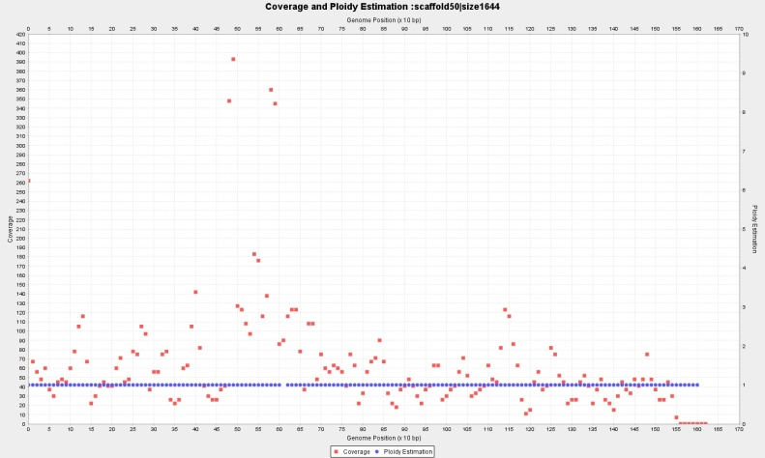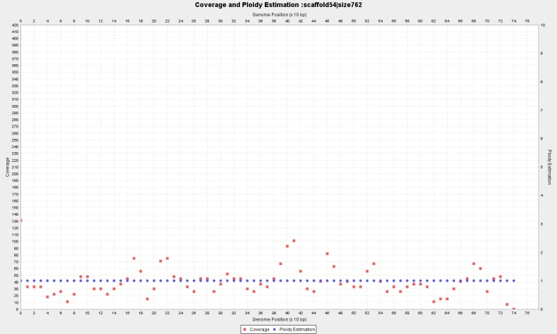

Contig 50 (1.644 bp) wl=20, with P={1} and Contig 54 (762 bp) wl=20, p=1

**Complete ploidy estimation for Novogene CBS1483**

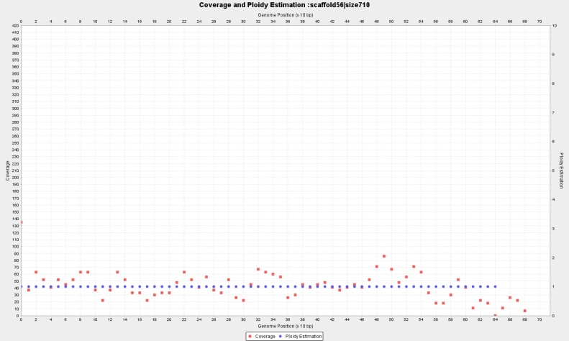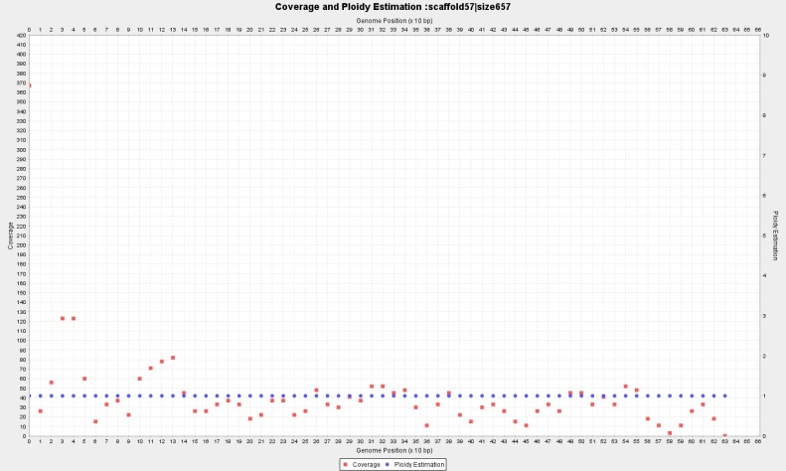

Contig 56 (710 bp) wl=16, with p=1 and Contig 57 (657 bp) wl=16, p=1

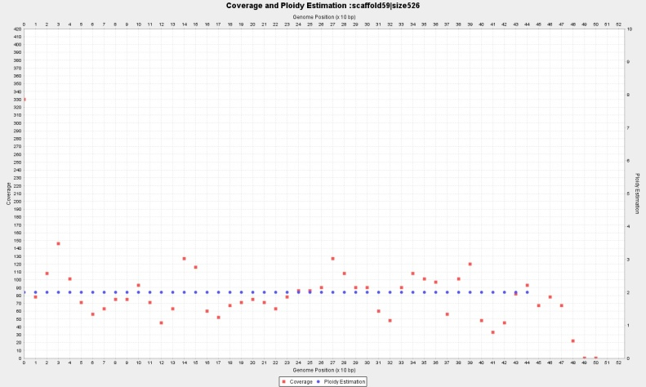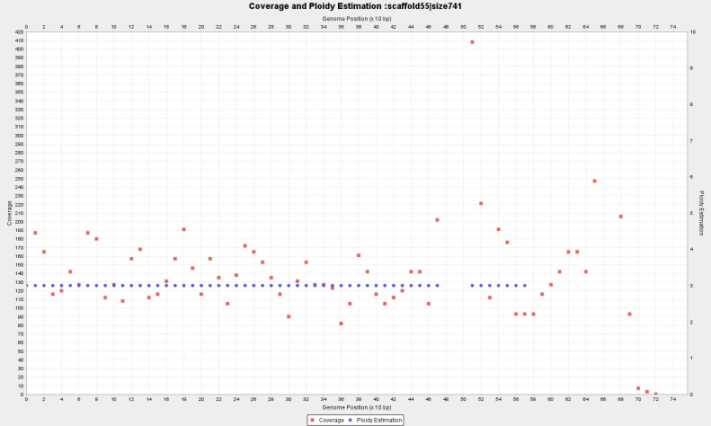

Contig 59 (526 bp) wl=16, p=2 and Contig 55 (741 bp) wl=20, p=3

# Mapping of CBS1483 Scaffold (van den Broek et al., 2015), to S.*cerevisae* S288 and S.*eubayanus* FM1318 reference genomes.

In order to evaluate our results we map the 59 contigs of the scaffold produced by (van den Broek et al., 2015) to S. pastorianus ancestors genomes. Sometimes, each scaffold maps to more than one ancestor chromosomes. We look at mappings in which at least 50% of the query scaffold aligns to at least 10% of the target ancestor chromosome. The following table shows the results. Headers: Percentage of the query scaffold mapped (‘%Query’) the name/number of the mapped scaffold (‘VdB 2015 scaffold #’) its size (‘Q size’). Next, the information from the target ancestor genome: percentage mapped (%Target) name/number of the reference chromosome and size. The last 7 columns display the ploidy estimations from the different methods. When a chromosome is fragmented with different ploidies, the estimations are order by decreasing length with p1 being the longest: ‘VdB p1-p3’ are the copy numbers estimated by Van den Broek et al. ; ‘Pedca Bc’, is the result of Pedca applied to the Baseclear sequencing. ‘Pedca Ng!=’ signals only the estimation divergences between Baseclear and Novogene, both using Pedca (‘!=’ different main ploidy from Baseclear, ‘+’additional fragment to Baseclear)

|  |  |  |  |  |  |  |  |  |  |  |  |  |
| --- | --- | --- | --- | --- | --- | --- | --- | --- | --- | --- | --- | --- |
| %Query mapped | VdB 2015  scaffold # | Q size (Kb ) | %Target mapped | Target  Reference | Reference size (Kbp) | VdB p1 | VdB p2 | VdB p3 | Pedca Bc_p1 | Pedca Bc_p2 | Pedca Bc_p3 | Pedca Ng != |
| 99 | 1 | 979.75 | 98.74 | SeubIV | 982.54 | 1 | 2 |  | 1 |  |  | !=1 |
| 82 | 2 | 1038.13 | 80.5 | SeubVII | 1051.73 | 3 |  |  | 3 | 4 |  |  |
| 18 | 2 | 1038.13 | 17.14 | ScerVII | 1090.94 | 1 | 4 |  | 3 | 4 |  |  |
| 56 | 3 | 890.82 | 45.56 | ScerVII | 1090.94 | 1 | 4 |  | 1 | 5 |  |  |
| 44 | 3 | 890.82 | 69.08 | ScerVIII | 562.64 | 5 |  |  | 1 | 5 |  |  |
| 99 | 4 | 1460.99 | 94.57 | ScerIV | 1531.93 | 3 | 3 |  | 3 |  |  |  |
| 100 | 5 | 777.50 | 95.49 | ScerII | 813.18 | 3 |  |  | 3 |  |  |  |
| 98 | 6 | 745.80 | 98.53 | SeubXV | 741.89 | 1 | 2 |  | 1 |  |  |  |
| 99 | 7 | 847.66 | 90.43 | ScerXIII | 924.43 | 2 | 4 |  | 2 |  |  |  |
| 99 | 8 | 741.10 | 81.84 | SeubXVI | 896.11 | 2 |  |  | 2 |  |  |  |
| 97 | 9 | 649.13 | 99.66 | SeubXI | 632.88 | 2 |  |  | 2 |  |  |  |
| 98 | 10 | 1262.41 | 96.77 | SeubII | 1274.80 | 1 | 2 | 3 | 1 |  |  |  |
| 99 | 11 | 637.73 | 94.77 | ScerXI | 666.82 | 2 | 3 |  | 2 |  |  |  |
| 91 | 12 | 923.77 | 88.56 | SeubXIII | 953.69 | 2 |  |  | 2 | 4 |  |  |
| 99 | 13 | 543.76 | 91.11 | SeubV | 588.91 | 2 |  |  | 2 |  |  |  |
| 39 | 14 | 747.09 | 39.24 | SeubX | 747.93 | 1 | 2 |  | 2 |  |  |  |
| 57 | 14 | 747.09 | 57.14 | ScerX | 745.75 | 2 | 1 |  | 2 |  |  |  |
| 99 | 15 | 742.08 | 77.6 | ScerXVI | 948.07 | 2 | 4 |  | 2 |  |  |  |
| 97 | 16 | 801.80 | 95.63 | SeubVIII | 813.83 | 1 | 2 |  | 1 |  |  |  |
| 99 | 17 | 556.22 | 71.62 | SeubXIV | 768.02 | 2 |  |  | 2 |  |  |  |
| 98 | 18 | 755.75 | 94.08 | ScerXIV | 784.33 | 2 | 3 |  | 2 | 3 |  |  |
| 75 | 19 | 463.27 | 32.15 | ScerXII | 1078.18 | 2 |  |  | 2 | 3 |  |  |
| 24 | 19 | 463.27 | 48.92 | ScerI | 230.22 | 3 | 4 |  | 2 | 3 |  |  |
| 100 | 20 | 398.15 | 90.58 | ScerIX | 439.89 | 3 |  |  | 3 |  |  |  |
| 98 | 21 | 823.16 | 73.82 | ScerXV | 1091.29 | 3 |  |  | 3 | 1 |  |  |
| 99 | 22 | 452.43 | 43.17 | SeubXII | 1033.98 | 2 | 4 |  | 2 |  |  |  |
| 99 | 23 | 443.17 | 40.6 | ScerXII | 1078.18 | 2 |  |  | 2 |  |  |  |
| 64 | 24 | 652.26 | 55.43 | SeubX | 747.93 | 1 | 2 |  | 1 |  |  | !=2 |
| 35 | 24 | 652.26 | 30.98 | ScerX | 745.75 | 2 | 1 |  | 1 |  |  | !=2 |
| 98 | 25 | 347.59 | 31.31 | ScerVII | 1090.94 | 1 | 4 |  | 1 |  |  |  |
| 100 | 26 | 392.54 | 97.34 | SeubIX | 401.36 | 2 |  |  | 2 |  |  |  |
| 65 | 27 | 292.64 | 61.83 | SeubIII | 305.62 | 4 |  |  |  |  |  |  |
| 35 | 27 | 292.64 | 32.17 | ScerIII | 316.62 | 4 | 3 |  |  |  |  |  |
| 95 | 28 | 463.10 | 42.75 | SeubXII | 1033.98 | 2 | 4 |  | 2 |  |  |  |
| 93 | 29 | 251.35 | 88.58 | SeubVI | 264.76 | 3 |  |  | 3 | 4 |  |  |
| 95 | 30 | 570.60 | 93.97 | ScerV | 576.87 | 3 |  |  | 3 |  |  |  |
| 94 | 31 | 208.41 | 17.89 | ScerXV | 1091.29 | 3 |  |  | 3 |  |  |  |
| 99 | 32 | 149.73 | 84.69 | SeubI | 175.44 | 2 | 1 |  | 2 |  |  |  |
| 56 | 33 | 147.91 | 7.64 | ScerXII | 1078.18 | 2 |  |  | 2 | 4 | 3 |  |
| 40 | 33 | 147.91 | 25.78 | ScerI | 230.22 | 3 | 4 |  | 2 | 4 | 3 |  |
| 89 | 34 | 259.47 | 85.75 | ScerVI | 270.16 | 1 |  |  |  |  |  |  |
| 100 | 35 | 117.96 | 11.41 | SeubXII | 1033.98 | 2 | 4 |  | 2 |  |  | +4 |
| 99 | 36 | 112.95 | 19.88 | ScerVIII | 562.64 | 5 |  |  | 5 |  |  |  |
| 96 | 37 | 173.01 | 21.7 | SeubXIV | 768.02 | 2 |  |  | 2 |  |  |  |
| 91 | 38 | 90.52 | 8.69 | ScerXVI | 948.07 | 2 | 4 |  | 4 |  |  |  |
| 71 | 39 | 77.90 | 6.17 | SeubXVI | 896.11 | 2 |  |  | 4 |  |  |  |
| 95 | 40 | 105.97 | 9.33 | ScerXII | 1078.18 | 2 |  |  | 2 |  |  |  |
| 48 | 41 | 73.25 | 54.55 | SeubMito | 64.00 |  |  |  | * |  |  |  |
| 99 | 42 | 28.80 | 3.73 | SeubXIV | 768.02 | 2 |  |  | 2 |  |  |  |
| 56 | 43 | 28.77 | 2.74 | SeubV | 588.91 | 2 |  |  | 4 |  |  | +5 |
| 91 | 44 | 19.65 | 10.17 | SeubI | 175.44 | 2 | 1 |  | 1 |  |  |  |
| 63 | 45 | 12.55 | 1.35 | SeubV | 588.91 | 2 |  |  | 4 |  |  |  |
| 100 | 47 | 2.41 | 0.22 | ScerXII | 1078.18 | 2 |  |  | 2 |  |  | +1 |
| 100 | 49 | 1.69 | 0.16 | SeubXII | 1033.98 | 2 | 4 |  | 1 |  |  |  |
| 77 | 50 | 1.64 | 0.08 | ScerIV | 1531.93 | 3 |  |  | 2 | 1 |  |  |
| 93 | 51 | 0.99 | 0.06 | ScerIV | 1531.93 | 3 |  |  | * |  |  |  |
| 91 | 52 | 0.95 | 0.06 | ScerIV | 1531.93 | 3 |  |  |  |  |  |  |
| 100 | 53 | 0.94 | 0.21 | ScerIX | 439.89 | 3 |  |  |  |  |  |  |
| 100 | 54 | 0.76 | 0.05 | ScerIV | 1531.93 | 3 |  |  | 1 |  |  |  |
| 100 | 55 | 0.74 | 0.1 | ScerX | 745.75 | 2 | 1 |  |  |  |  |  |
| 100 | 56 | 0.71 | 0.05 | ScerIV | 1531.93 | 3 |  |  | 1 |  |  |  |
| 100 | 57 | 0.66 | 0.28 | ScerI | 230.22 | 3 | 4 |  | 1 |  |  |  |
| 96 | 58 | 0.62 | 0.93 | SeubMito | 64.00 |  |  |  |  |  |  |  |
| 95 | 59 | 0.59 | 0.95 | ScerMito | 85.00 |  |  |  | 2 |  |  |  |

# Ploidy estimation for Tripanosoma cruzi BroadTcVICLBrener alignment (wl=1500bp)

